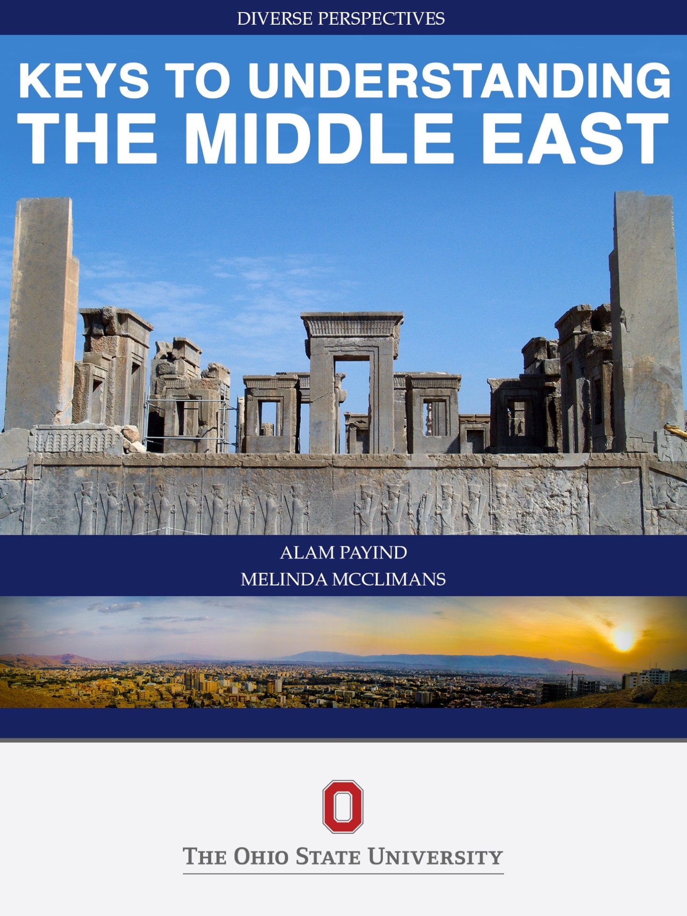

# Keys to Understanding the Middle East

By Alam Payind and Melinda McClimans

#### Cover images:

Above: Persepolis, Tachara Palace Credit: “Persepolis, Tachara Palace “ Photo by درفش کاویانی, source: Wikimedia Commons, License: CC BY-SA 3.0

Below: Shiraz, 22 October 2009, Shiraz, Fars Province, Iran, near the site of Persepolis Credit: “A Panoramic view of City of Shiraz from a hill near to Shahid Dastghayb Dormitory in Shiraz University complex.” Photo by:Mahyar Ebrahimi, Source: Wikimedia Commons, License: Creative Commons 3.0

Copyright:

Keys to Understanding the Middle East by Alam Payind and Melinda McClimans is licensed under a [Creative Commons Attribution-ShareAlike 4.0 International License](https://creativecommons.org/licenses/by-sa/4.0/), except where otherwise noted.

This work is licensed under Creative Commons 2.0. Any use of this material must include an attribution to the authors, Alam Payind and Melinda McClimans, and must indicate if any changes were made to it. Any publication using this material must be distributed under the same license as this one.

# Table of Contents:

Acknowledgments 5

Approach of this book 7

Introduction 8

A Note on Language 10

Romanization Chart 12

Defining the Middle East 14

Common Misconceptions 16

Chapter 1 Languages 18

Writing, A Major Cultural Contribution of the Middle East 18

Chapter 2 Linguistic Groups 21

Middle Eastern Linguistic “Family Tree” charts 22

Chapter 3 Arabic’s Influence in the Region 24

Chapter 4 Islamic Expansion 27

Early Islamic Expansion Under the First Four Caliphs 29

Early Islamic Expansion Timeline 29

Chapter 5 Faith and Religious Identity 30

Sacred Places of the Middle East 31

Sacred Places Images 31

Chapter 6 Diverse Religious Identities of the Middle East 33

The Abrahamic Faiths 34

Abrahamic Religions Comparison Chart 35

Chapter 7 Religious Diversity 37

Chapter 8 Islam in Middle Eastern Societies 39

The Concept of Jihad 40

Chapter 9 What is Shar'ia Law? 41

Chapter 10 Religious Pluralism 42

Chapter 11 Prayer, A Part of Daily Life for Muslims Around the World 43

Image Gallery, Expressions of Muslim Prayer 43

Chapter 12 Shi'ism 43

Shi’i Leadership Genealogy: 45

Chapter 13 The Mystical Tradition of Sufism, or *Tasawwuf* 47

Image Gallery, Legendary Sufi and Mystic, Maulana Jallaluddin Rumi Balkhi 47

Chapter 14 Who are the Salafis/Wahabis? 49

Chapter 16 The Middle East and the Impact of Imperialism 50

Chapter 17 Defining the Term “Middle East” 51

Chapter 18 National Borders as Foreign Intervention 52

Chapter 19 The Impact of Imperialism on the Region 53

Key Figure: Mohammad Mossadegh Prime Minister, Iran, 1953 55

Key Figure: Ayatollah Khomeini 56

Chapter 20 Modernization Versus Westernization 58

Images of Modernizing Leaders 59

Chapter 21 Gamal Abdul Nasser and Non-Alignment 60

Key Figure: Gamal ‘Abdul Nasser 60

Chapter 22 Nation States and Stateless Nations 62

Key Concept: Stateless Nation 63

Key Concept: Minoritization 63

Chapter 23 The U.S. and Post-Bandung Imperial Dominance 65

Key Event: Bandung Conference of 1955 65

Maps of the Alliances of the Cold War Era, Visual of “Containment” 66

Chapter 24 *Conclusion* 68

Cited Sources 71

The Middle East Studies Center at the Ohio State University 74

Glossary 75

# Acknowledgments

*This book is dedicated to the many students who have enrolled in International Studies “Introduction to the Modern Middle East” and “Contemporary Issues in the Middle East” over the years. These have been offered at Ohio State University (OSU) since 1986, when Dr. Payind began teaching them, and continue to enjoy high enrollments. We thank International Studies, which hosts the courses. We especially thank Karlene Foster for her years of service. We thank the Department of Near Eastern Languages and Cultures for collaborating with us to create effective multidisciplinary content in the Intro course, for cross-listing the Contemporary Issues course, and for integrating both into their curricula.*

*This material has been continually honed by student feedback over the years. We thank them for their curiosity, which inspires us continually.*

*We are grateful to many individuals who supported us on this project and made it possible. Among some of the most important, are:*

*Kelechi Kalu, Associate Provost, International Affairs, OSU, for his enthusiasm and unhesitant approval for us to dedicate our time to this project. He is a model of the joy that can come from curriculum.*

*Linda Montano, Senior Director of Business Operations and Administration, International Affairs, OSU, for the moral support and the business expertise we needed to ensure the project’s success.*

*Kirti Jain, Budget Analyst, International Affairs, OSU, for creating the fiscal structures for this project that have helped it progress smoothly.*

*Patricia Palominos-Dunaeff, Human Resources Manager, International Affairs, OSU, for ensuring skills were properly aligned with the work, hiring fast when we really needed the help, and providing ongoing support.*

*Ashley Miller, Program Manager, Affordability and Access, Office of Distance Education and e-Learning, for inspiring us to begin this, keeping us on track, and shepherding us to the finish line. We thank Ashley also for sharing her immense knowledge of best practices.*

*Michael Shiflet, Educational Technologist, Affordability and Access, Office of Distance Learning, OSU, for designing the templates, optimizing our aesthetics, creating maps for us, and scaffolding our learning of the technical tools we used. Thanks so much for the ongoing support.*

*Tyler Parker, Student Assistant, International Affairs, OSU, for image research, proof-reading, fact-finding and many other aspects of support in the completion of this e-book.*

*Danielle Cooke, Fiscal and Program Associate, International Affairs, OSU, for copy editing, very helpful feedback on the text, and for facilitating the image purchase. What a relief it is that she is here!*

*We thank all of the faculty members who we have hosted as guest speakers in “Introduction to the Modern Middle East”, over the years: Jane Hathaway, Carter Findley, Reuben Ahroni, Sabra Webber, John Quigley, Miroslav Ruzic, Predrag Matejic, Shaula Gurari, Naomi Brenner; Alex Kaye, and others. We especially thank Sam Meier, for direct input into this project. We thank Johanna Sellman, Professor and Middle East Studies Librarian, for her ongoing encouragement of this, and all of our outreach.*

*We thank the members of our OSU e-books cohort for providing feedback, useful suggestions and a sense of community.*

*We are honored to have had this opportunity to work with all of of the individuals mentioned above, and many others too numerous to mention.*

# Approach of this book

Images are an important aspect of the information presented throughout this text. Because our approach is to connect history to the present, artifacts from ancient civilizations feature prominently. On the cover: the ancient Persian capital of Persepolis with the city of Shiraz, Iran. Several pages of the conclusion show multiple images/perspectives on Giza, district of Cairo where pyramids are situated. Each chapter starts with links to its visual aids.

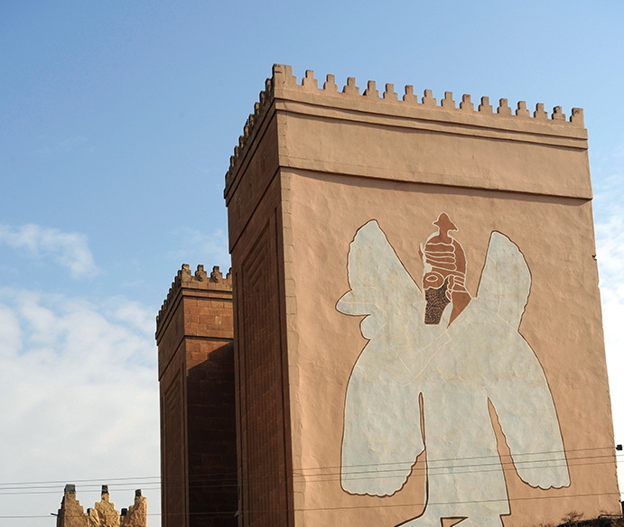

*Image of the Ancient gate of Ninawa, the Nergal Gate mentioned in the Bible. A provincial reconstruction team and representatives of the United Nations Educational, Scientific, and Cultural Organization visit what remains of Nergal gate in Nineveh, Iraq, Nov. 22, 2008. Nineveh, built between 704-681 B.C., was a capital of the Assyrian Empire and was surrounded by a 12-kilometer mud brick wall. (U.S. Air Force photo by Staff Sgt. JoAnn S. Makinano/Released)*

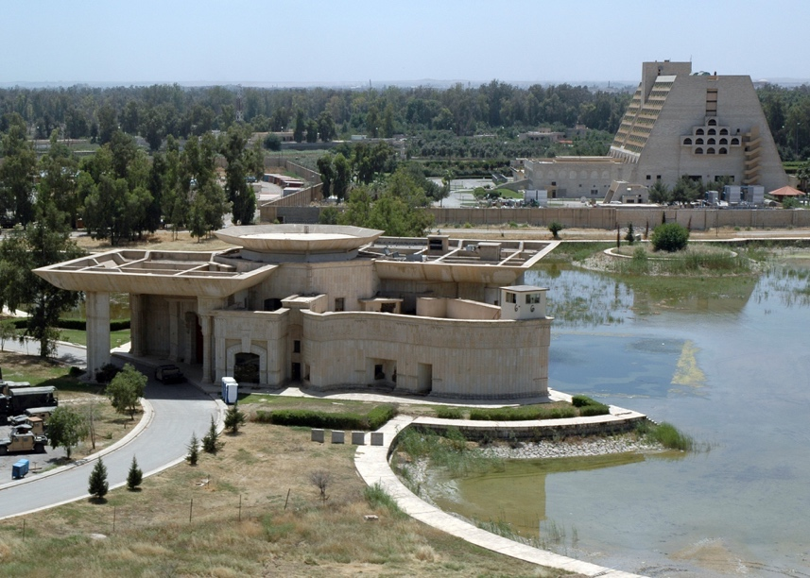

*Image of Saddam’s Palace in Ninawa, one of the palaces used by Saddam Hussein in Mosul, northern Iraq, Ninawa (Nineveh) province.  US Army Corps of Engineers (USACE) photograph by ACoE photographer Jim Gordon, C.C.0, via Wikimedia Commons.*

# Introduction

This book is intended for readers who have never studied the Middle East, or who would like to improve their knowledge of the region. Key concepts are demarcated with text boxes throughout, and a glossary is provided which includes those and other important words from each chapter. This book is intended as a starting point for insider literacy. This is why we provide key terms in the local languages as much as possible. This is not a history book, although we discuss milestones and key historical figures within the contexts of ancient and modern civilizations. Our goal is for the reader to understand some introductory perspectives coming from within the region, and begin building knowledge regarding what informs them. We consider it important not to advocate for a particular community’s view, but to challenge readers to understand multiple perspectives. Whether the reader is a novice or scholar, we expect these fundamentals will be of value. These include: the languages, the cultural, religious and sectarian communities of the region, and turning points in history, such as:

* The establishment of the early Islamic Empires which played a key role in establishing Arabic as a dominant language in the region.
* The schism of Islam into Sunni and Shi‘i factions, which continues to shape the region today.
* The legacies of imperialism, the Cold War and Global Alliances such as NATO, which continue to impact the region.

The choices we’ve made regarding what to include are informed by what we have been repeatedly told by many of the students in our classes. There are many more languages, religions and cultural communities in the region beyond what we could cover here, but we do our best to acknowledge as many as possible. Whether the reader is a novice or scholar, we expect these fundamentals will be of value.

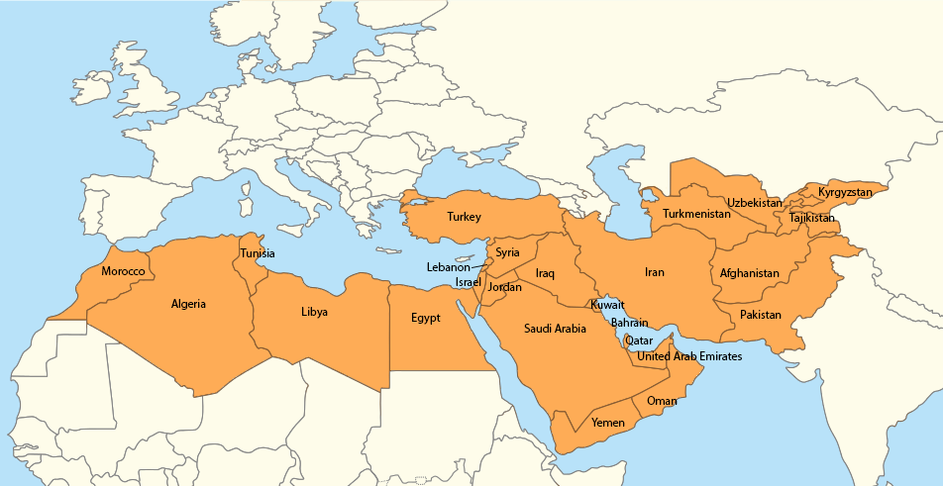

*Map of the Greater Middle East, including North Africa, and Central Asia. Image credit: “Location map for Middle East (Greater Middle East)” by 배우는사람 (talk), Wikimedia Commons, CC.0*

The following chapters focus on the languages, cultural, religious and sectarian communities of the region, and certain turning points in history which are keys for understanding the region, whether for establishing a new knowledge base, or deepening one’s knowledge. In addition to language and nationality (or ethnic identity), religious communities play a huge role in the Middle East. We therefore cover, language communities, cultural communities and religious communities which combine to create many unique, complex identities of the Middle East.

Chapter one focuses on the languages spoken in the region. The countries we have included (see chart, next page) possess a significant population of speakers of one or more of the following languages: Arabic, Hebrew, Persian or Turkish (or, closely-related Turkic languages). Chapter two also acknowledges some of the ancient languages of the Middle East with global significance in regard to such innovations in human culture as writing.

Chapter two provides an overview of some of the major religious identities of the region, past and present. It also addresses the religious diversity and importance of minority religions and factions within major religions. Islam is explored in detail, especially in relation to multiple schools of thought and the premises of Islamic law. Except for Israel, each of these states are also Muslim-majority. This book acknowledges the major cultural influence Islam has had on the region, as well as its religious diversity.

Chapter three covers critical developments in the Middle East related to the effects of European colonialism in the region and the Cold War. The chart on the previous page shows which countries we cover, along with their Muslim populations. Please keep in mind, however, that the Muslim population of the Middle East makes up only 42% of the total worldwide Muslim population (Pew, 2011 – see chart below). Furthermore, we are using one of the broadest definitions of the Middle East possible in this book.

**Muslim-Majority Countries of the Middle East**

|  |  |  |
| --- | --- | --- |
| Middle Eastern Country | Population* | Percent of Muslims Worldwide |
| Afghanistan | 29,047,000 | 2% |
| Algeria | 34,780,000 | 2% |
| Bahrain | 655,000 | 0% |
| Egypt | 80,024,000 | 5% |
| Pakistan | 178,097,000 | 11% |
| Palestinian Territories | 4,298,000 | 0% |
| Iran | 74,819,000 | 5% |
| Iraq | 31,108,000 | 2% |
| Israel | 1,287,000 | 0% |
| Jordan | 6,397,000 | 0% |
| Kazakhstan | 8,887,000 | 1% |
| Kuwait | 2,636,000 | 0% |
| Kyrgyzstan | 4,927,000 | 0% |
| Lebanon | 2,542,000 | 0% |
| Libya | 6,325,000 | 0% |
| Morocco | 32,381,000 | 2% |
| Oman | 2,547,000 | 0% |
| Qatar | 1,168,000 | 0% |
| Saudi Arabia | 25,493,000 | 2% |
| Syria | 20,895,000 | 1% |
| United Arab Emirates | 3,577,000 | 0% |
| Tajikistan | 7,006,000 | 0% |
| Tunisia | 10,349,000 | 1% |
| Turkey | 74,660,000 | 5% |
| Turkmenistan | 4,830,000 | 0% |
| Uzbekistan | 26,833,000 | 2% |
| Yemen | 24,023,000 | 2% |
| Total of Selected Countries | 699,591,000 | 44% |
| Total Muslim Population | 1,600,000,000 | 100% |
| Source: http://www.pewforum.org/2011/01/27/table-muslim-population-by-country/ | *as of 2010 |  |
| Data sources: | <http://www.pewforum.org/2011/01/27/table-muslim-population-by-country/> | |
|  | http://www.pewforum.org/2015/04/02/muslims/pf_15-04-02_projectionstables74/ | |
|  | Pew Forum, Muslim Population Data | |

# A Note on Language

Because of our decision to use Arabic vocabulary for identifying culturally important terms that relate to Islam and pre-Islamic concepts, we need to address the issue of Arabic being written with the Arabic alphabet.  Transliteration is the system for rendering Arabic sounds, which are normally written in the Arabic alphabet, into the Latin alphabet which is used by most European languages (and modern Turkish). There is a lot of local variation in how these are actually pronounced.  However, as mentioned above, we have chosen to present Arabic words according to their pronunciation in Classical Arabic for the sake of clarity and consistency.

Romanization Chart

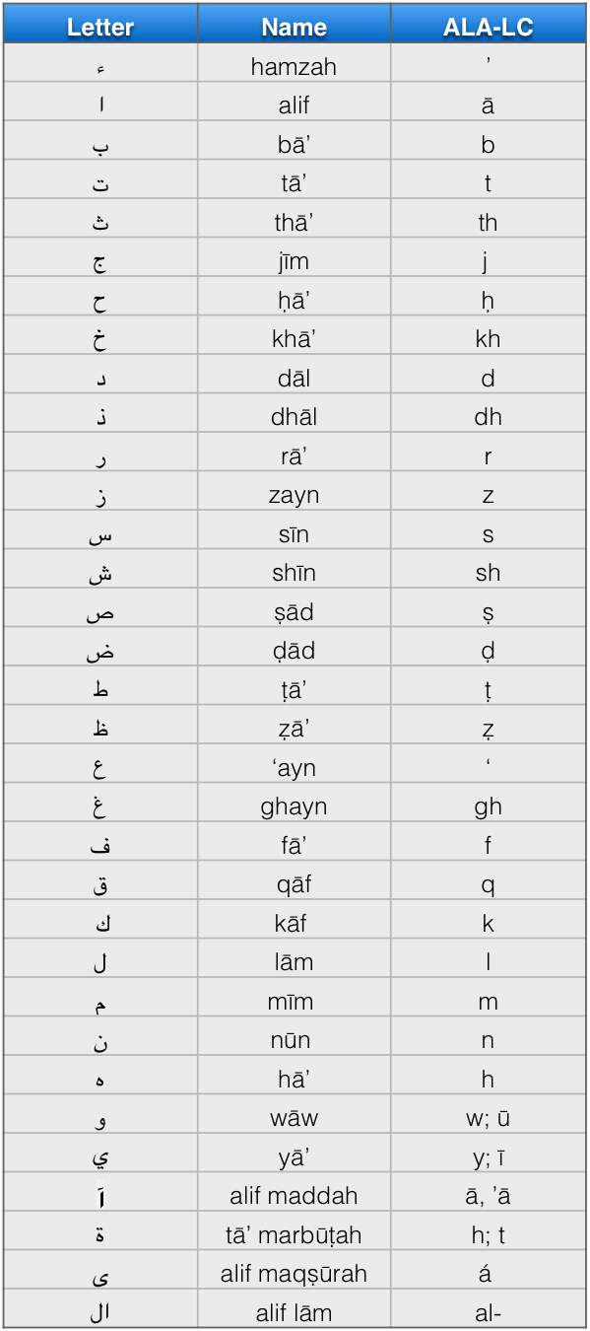

For the system we use to represent Arabic sounds in the Latin alphabet, please see the Romanization chart above, based on the American Library Association’s system. This chart is based on pronunciation of classical Arabic.  Despite our choice of classical Arabic pronunciations, there are many classical pronunciations, that in reality are quite rare in the Middle East, even in Arab countries.  Dh, for example: in some Arabic-speaking countries the dh pronunciation remains similar to classical, but it is usually pronounced zh.  Thus, Ramadhan becomes Ramazhan in many local contexts.

# Defining the Middle East

The region we are covering spans from Morocco to Afghanistan, and is unified by many cultural and linguistic ties, as well as many shared worldviews that are reflected in the religions of the region, as well. The list of countries we include in our definition can be found in the chart on page 6, and a detailed definition can be found in chapter 3 (“Defining the the term ‘Middle East’”).

The diversity of the Middle East is the main learning outcome we intend for our readers because the region is often spoken of in monolithic terms. However, humanity also is unified by many shared experiences of the human condition. To think critically about other parts of the world, engage with both similarities and differences: recognize that interconnectedness doesn’t mean uniformity. Saadi Shirazi (1210 – 1291 A.D.) had some wisdom on this subject (Payind’s translation):

“Humans are organs in the same body, created from the same essence If one organ feels pain, the other organs will not restrain. If you are indifferent about the sufferings of others, you shall not deserve the name ‘Human.’”

While differences lie at the core of human experience, humanity remains united in many ways. Sometimes differences can be contentious, or politicized, especially with regard to the Middle East. These are difficult issues, but it is very important to discuss them, and learn from people and places that are different from you. Differences do not need to lead to conflict or the inability to communicate.  Develop the habit of taking different perspectives into account; gain what Robert Hanvey called “perspective consciousness” (1982), and you will become resilient enough to engage with different perspectives.

Individuals in the Middle East often represent an amalgam of communities.  The mother tongue, the DNA, and the geographic location of “home” come from personal and family history that may include a wide array of different religious or sectarian affiliations, individuals who speak/spoke Arabic, Aramaic, Hebrew, Yiddish, Kurdish, Persian, and/or Turkish, for example.  While experts of the region can guess what someone’s religion is through name, etc., it can be very difficult to tell, even for insiders, from such superficial indicators what a person’s cultural heritage is exactly. Even as we strive to be inclusive in this book, there are many groups we neglected, such as Druze, ‘Alawite, Samaritan, and others, that we hope the reader will investigate upon learning about the region’s complexity.

The geographic area we are covering expands beyond common definitions of the Middle East, which do not always include Central Asia (Afghanistan) or North Africa (Morocco). We include Turkey which is in a liminal space with regard to cultural and geographic boundaries, resting on the border between Europe and Asia. Its predecessor, the Ottoman Empire, was comprised of many of the countries that are what we now consider part of the “Middle East”. Turkey, Arab countries and much of the Balkans were born out of its ashes. These countries do not define the region, however, as Iran, Afghanistan, and other countries within the Persian cultural sphere are hugely influential. We include all of those areas because of shared history, common languages, and the practices of Islam which have been a powerful cultural force in the area. The term “Middle East” is contested, and its definition has changed dramatically over time, and depending on context. Chapter Three addresses the related issues and gives our definition.

The theory and information herein is intended as a filter incoming information you encounter. Understanding the diversity of the region is the best starting point for developing this analytical lens, and for breaking down the narratives and images which are prominent in entertainment, advertising news media and other official, and unofficial, sources of information one may encounter on a daily basis. Learning about daily life in the Middle East, and languages, beliefs and historical contexts for it encompasses the major aspects of identity each individual from the region possesses.

# Common Misconceptions

Engaging our readers with the rich diversity of the region is our main goal, but in order to be more effective in that effort, we need to address a few conceptual barriers. Humans are not born with an awareness of cultural difference; exposure to difference is necessary in order to gain that awareness. Often the exposure to places outside of one’s immediate experience is filtered by historical representations that focus on what early explorers thought were significant, or which governments used as propaganda, or which marketers used to entice the public, etc. The following misconceptions will help dispel these notions, and provide a clean (er) slate on which to build knowledge.

The most pervasive misconception that can obscure objective thinking about the Middle East is the idea that throughout history **certain civilizations “progressed,”** and others lagged behind.  This **“evolutionary” historical construct**(Anderson, 2006) frames history in terms of progress from primitive to advanced. It forms the basis of the perception that many communities were only significant in the past, and tends to represent such communities as primitive, or as though they are still living in the past. The Middle East, especially, is framed in terms of a glorious past, often relegated to the study of ancient history. **Intentionally, or unintentionally, many of the sources of information one encounters tend to negate the present reality because of this.**

In addition to the way this region is often portrayed as trapped in antiquity, repeated images of violence, exotic “others” and stereotypes have deeply infiltrated the way it is seen. The Western knowledge base contains biases which harken back to historical power struggles between the Egyptians and Hittites, the Greeks and the Persians, the Eastern Romans (Byzantines) and the Persians, and later the Austro-Hungarians and the Ottomans, after Constantinople fell in 1453.  These give us a historical sense of the “East vs. West” divide. This divide was reified and accelerated during the era of European global colonization.   Despite this perceived “us vs. them” difference, however, people in the West share many of the same cultural roots of the Middle East.  These communities overlapped a great deal.  Greek culture, which is considered a cultural foundation for Europe, was spread by Alexander into as far as what is now Afghanistan and Pakistan, for example.   Furthermore, Persian civilizations and Turkic communities had a deep and lasting impact on the literatures, philosophies, and sciences of Western civilizations.

Civilizations worldwide have adopted, and continue to adopt, many scientific developments from the region. From the pre-industrial era, all the way back to antiquity, in the times of the Sumerians, Greeks, Persians, Romans and Ancient Egyptians. Some examples from the past include innovations in: writing, astronomy, optics, hydraulics, textiles, decorative arts, crop rotation, urban planning, irrigation, geometry, mathematics, organized libraries and universities, means of financial exchange, theological and philosophical achievements, and other developments from the region have had a significant impact on Europe and the world. Today, Middle Eastern countries are contributing to scientific breakthroughs, such as the growing of liver cells, participating in the research at CERN, soil desalinization, and many others.

In the following chapters, we discuss three main elements of Middle Eastern identities that are intended to counter the stereotypes and over-generalizations that can misconstrue one’s understanding of the region: cultural and linguistic diversity; the role of religion in forming diverse cultural identities and perspectives; and the impact of outside influences, and in particular in the form of Western imperialism.  Chapter One is an overview of one of the key elements of cultural diversity, language groups and linguistic history. We describe religious and sectarian beliefs and cultural significance in detail in Chapter Two. Chapter Three is dedicated to imperialism. Out of the 49 Muslim-majority countries today, only 4 were never colonized: Iran, Afghanistan, Turkey, and Saudi Arabia. We briefly discuss the implications of European global power struggles and wars in the region, as well as the encroachment of European institutions into local economies and ways of life.

# Chapter 1 Languages

Writing, A Major Cultural Contribution of the Middle East

Writing, or the representation of meaning through symbols and images, is an artifact of great historical and cultural importance. The Middle East is the birthplace for many forms of written language, including several phonetic alphabets which provided the breakthrough of representing sound through visual media. Artifacts (see below) of various scripts show the diversity of the cultural influences and how they have evolved over time. In addition to writing systems now strongly associated with the Middle East, such as Arabic and Hebrew, scripts developed by Assyrians, Egyptians, Babylonians, Sumerians, and Ancient Greek systems, such as linear B, are included. These samples demonstrate the widespread geographic influence these civilizations have had, from North Africa, to West Asia, and to the Indian subcontinent.

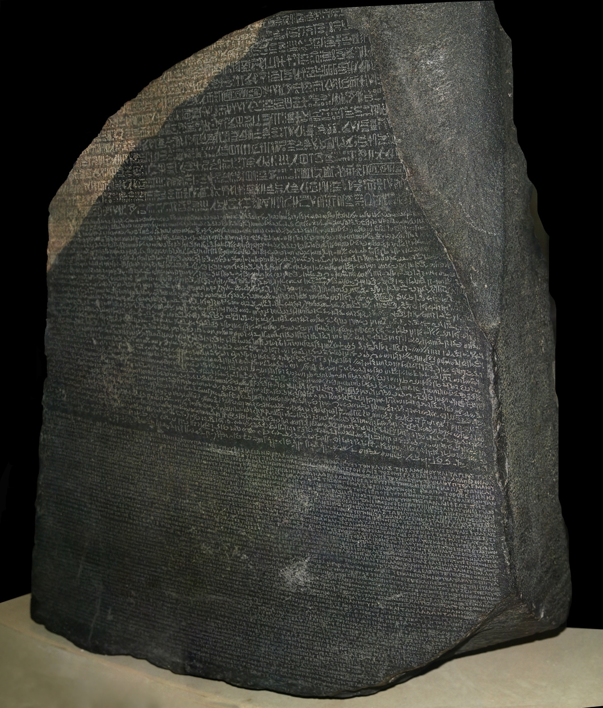

*The Rosetta Stone, with inscriptions in Hieroglyphics, Egyptian Demotic and Greek. The inscriptions were of the same message, but in different languages and writing systems. It was the most critical artifact in the scholarship which finally would decipher Ancient Egyptian Hieroglyphics. Discovered by Napoleon’s team of scholars in Rosetta, Egypt, in 1799, this artifact now symbolizes the act of decoding and uncovering lost knowledge. “Rosetta Stone” by Hans Hillewaert, from Wikimedia Commons, licensed under CC BY-SA 4.0*

The samples in the image gallery linked to below serve as introductions to linguistic history of the Middle East. These examples continue to have relevance today, whether continued as a form of spoken language, a liturgical language used in worship, or as a medium for conveying important cultural ideas. Arabic, Hebrew, and Greek have survived as living languages, still spoken by significant numbers of people. There are still people in Syria who speak Aramaic, also known as Syriac, as their native tongue. Ancient Egyptian continues through to the present day as the liturgical language used in the Coptic church. Arabic and Hebrew outlived the others, however, as the most actively used writing systems.

The primary living languages of the Middle East today are Arabic, Hebrew, Kurdish, Persian and Turkish. Pashto is another language spoken by a significant number in Afghanistan, while other Turkic languages closely related to Turkish, such as Turkmen, Uzbek, and others are important. Tajik and Dari are forms of Persian spoken in Afghanistan and Tajikistan. Arabic has a unique place amongst the writing systems due to its place in Islam, and Islam’s impact on the region. Many of these languages use, or have used Arabic script in the past, as their writing system. We therefore cover Arabic and its influence in sections, “Arabic’s Influence in the Region”, and “Islamic Expansion”.

Image gallery of early forms of writing: <https://ohiostate.pressbooks.pub/key2mideast/chapter/languages/#earlywriting>

# Chapter 2 Linguistic Groups

This chapter is an overview of the diversity of the region in regard to linguistic groups. Local language is a key to mapping the diversity of Middle Eastern identities. While linguistic boundaries do not always obey national boundaries (in the Middle East, more often, they do not), they provide a picture of the diversity of the cultural landscape. Cultural identity and the communities that shape how individuals are seen in greater society go beyond static definitions of culture, ethnicity or nationality, and can easily be oversimplified in an introductory text, such as this one. Focusing on the “cultures” of the Middle East can be quite problematic because boundaries can be hard to define. Further, the notion of a static “culture” notion of culture can lead to categorizations of communities according to “characteristics” that can be misleading (Rogoff,2003). The focus on history is not to relegate these communities to the past, but to incorporate the element of time and to explore an important aspect of culture, language, which exhibits stability and change. Languages convey information about long histories more than national borders do.

Constructed over time, languages continually change while retaining stable patterns of meaning. Through this process, some communities eventually develop their own versions of these patterns, and lose the ability to communicate with their previous communities, and a dialect is formed. Deep historical connections and divides between cultural/linguistic groups are revealed through evidence found in patterns of speech. Divides occur when two ways of speaking lose their mutual intelligibility, or the ability of one speaker to make him or herself understood to the other and vice versa, they become separate dialects or languages. Languages branch off of the main group, then split again within themselves. When visually rendered, this forms a sort of language family tree (see Middle East language “family trees” below). The issue of when a new form of speech constitutes a new dialect or a full-fledged language is often highly contentious. Many of the Middle Eastern languages we touch on in this chapter consist of numerous sub-dialects, which are mutually intelligible, semi-intelligible or barely at all. It is a spectrum, rather than a definite line. According linguist P.H. Matthews:

“what count as separate ‘languages’ for specialists in one part of the world are often much more like each other than the ‘dialects’ of a single language as described in others.” (2003,p.77)

When such differences are used as grounds for discrimination, or become politicized, it can be challenging to get a straight answer from anyone about the status of a language. Language is profoundly and universally tied to cultural identity and social experience. Be cognizant of this factor as you continue to learn about the languages of the Middle East, and their connections (and dissonances) with national identity; particularly when a language is overtly tied to citizenship and cultural loyalty in the popular culture.

The many languages that exist in the region can be grouped into three large linguistic categories. They are listed below, and we have provided them in chart form below.

* Semitic Languages (Arabic, Hebrew, Aramaic/Syriac and others)
* Iranian Languages (Pashto, Persian (Dari, Tajik), Baluchi, Kurdish and others)
* Ural-Altaic Languages (Turkish and other Turkic languages, such as Uzbek, Kyrgyz, and Azeri/Azerbaijani).

Semitic languages are important due to the histories of the Ancient Semitic civilizations, such as Sumeria, the Hebrew communities, Arab communities and Aramaic-speaking communities of today. Abraham was an Akkadian speaker, and Jesus’s native tongue was Aramaic. Aramaic is also one of the important languages of the Talmud, or the scriptural exegesis made by prominent Jewish scholars regarding the Torah. Hebrew is the traditional language of the Jewish people, and has become a living language again in Israel, since the late 19th century. It is the language of the central Jewish scripture, the Torah. Arabic is another other majorly influential Semitic language which we will cover in the next section.

Persian is the main language spoken in Iran, Afghanistan, and Tajikistan. Being an Indo-Iranian language, and part of the Indo-European family of languages, it is much closer to English in structure than the Semitic or Turkic languages. Thus, it takes less time for a native English speaker to learn Persian than to learn Arabic, Hebrew or Turkish. Persian/Iranian words continue to play a major role in the languages of the Middle East and beyond. Many of the cultural practices of the Persians are reflected in modern words. Horsemanship words, for example, often reflect Persian origins. The word for stable in Persian in *estabel*. The word *diwan*, meaning collection of high literature, is still an important word in the Middle East. Practices from Achaemenian, Sassanian and other Persian civilizations show up in modern concepts of literature, the arts and courtly life.

In order to put the language “families” in context, consider Persian in relation to European languages – they are both part of the same linguistic “family tree” (see chart, below). It is not hard to deduce that English and Persian have a common ancestor. One of the ways linguists determine a language’s origins is by looking at “old words”; that is, words which represent concepts with a long history in the community. The words for family members are analyzed in this regard, as family experience is a fundamental human experience. The word “daughter” in English reveals through its spelling a previous pronunciation in which the “gh” was pronounced something like the “ch” in German. German retains this pronunciation in its word for daughter: *tochter*. The Dutch word is *dokhter*. The word in Persian is also *dokhter*. Mother is *Madar* in Persian, Father is *Padar*, Brother is *Biradar*. These are pieces of evidence that English, German, Dutch and Persian share a common ancestor, and thus, common cultural community from the distant past.

Middle Eastern Linguistic “Family Tree” charts: <https://ohiostate.pressbooks.pub/key2mideast/chapter/linguistic-groups/#lingfams>

Turkic languages include modern Turkish, and are an additional highly influential group in the region. Rooted in nomadic cultures, Turkic-language-speaking communities migrated westward in waves from Central Asia, over the centuries. These groups made an impact in world history in numerous ways. Mamluks, Seljuks and later Ottoman civilizations enjoyed some of the highest levels of culture, medicine and science in the Middle East region and perhaps the world. These and other Turkic communities took on the leadership of Islamic expansion after the Arabs, eventually taking Constantinople. They made numerous significant contributions to the past and current cultural landscape of the region. The expanse over which Turkic languages spread is remarkable (see [map](https://upload.wikimedia.org/wikipedia/commons/c/c2/Linguistic_map_of_the_Altaic%2C_Turkic_and_Uralic_languages_%28en%29.png) on the web of Ural-Altaic linguistic groups), reflecting the nomadic migrations of these communities throughout history.

# Chapter 3 Arabic’s Influence in the Region

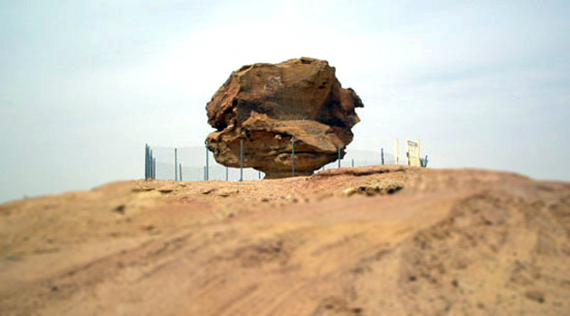

*This rock is supposedly the same rock mentioned in the stories of ‘Antara. These epics and love stories are still recited in coffee houses today. Antara dates to pre-Islamic times in the Arabian Peninsula, and was himself a famous poet, while also being the hero of many poems and stories. “A recent photo of what is said to be the famous Rock where Antarah used to meet Abla” By AzizRP, via Wikimedia Commons, C.C*

This section seeks to convey the importance of Arabic as a language which came to be spoken far beyond its place of origin, and which also gained influence on a large geographical area through the conquest of Islam.  We also seek to address a unidimensional view of Arabic as the only linguistic influencer of the region. Indeed, Greek and Persian both had significant impacts on Arabic, both conceptually and in the form of many borrowed words.  The major powers of the area when Islam came into being, the Eastern Roman, or Byzantine Empire, and the Sasanian Empire, spoke Greek and Persian respectively.

Arabic forms an initial basis for understanding many of the most important concepts shared by members of the larger Muslim *umma*, or Muslim community, within many diverse cultural communities. For example, the word *sunna*. A revered word when used in the context of the Prophet’s Sunna. Before the prophet *sunna* was a path worn into the sand, hardening the sand with perpetual use. It came to stand for tradition. In Bedouin culture, the nomadic culture of the Arabian Peninsula, such paths were very important, as unknown territory could be deadly. Over time, the word may have stopped emphasizing the original cultural reference, but it has kept the meaning of correct path. The term Sunni, as in Sunni Muslims, means those who are following the right path; in this case, the path refers to the traditions of the Prophet.

Arabic and many aspects of Arab culture spread worldwide through Islam; one could justifiably consider early Islamic conquests, Arab conquests. Before Islam, there was a vibrant literary culture in the Arabian Peninsula. The Ka’aba, now known for being the global center for pilgrimage, was already a pilgrimage site, and the place where the best poems were displayed or “hung”. One of the masters of these “Hanging Poems” was ‘Antara, and his poetry depicted a love relationship with ‘Abla. The picture on the previous page is supposed to show the rock they used as a meeting point in his poetry.

‘Antara’s significance lies in the significance of pre-Islamic Arab society. The language of the Qur’an refers to that cultural milieu a great deal, and many of the early Arab cultural practices inform Islamic concepts. Thus, remnants appear in Islamic law, religious and social practices, aesthetics, etc., in Muslim communities, regardless of whether they are native speakers of Arabic.

The cultural connections between Arabic and Islamic make it exceedingly easy to conflate “Arab” and “Muslim”. The largest Muslim-majority country in the world, and the fourth most populous country worldwide, Indonesia, is neither Arabic-speaking (as mother tongue), nor in the Middle East. As we pointed out in the Introduction, the Middle East is only a small portion of Muslims worldwide, and only 16 of the 25 countries in our geographical definition of the Middle East are Arab-majority countries. Thus, Arab-majority countries are all within the Middle East (according to our definition), but not all Middle Eastern countries – or Muslim-majority countries – are Arab (Israel is Jewish-majority).

There is some validity to the connection between Arab identity and Islam, however. The Qur’an is in Arabic; and the Sunna, or the authenticated accounts of the prophet’s words and actions, are in Arabic. Thus, the terminology in non-Arabic-speaking, Muslim-majority countries for them is in Arabic. Most Muslim-majority countries also have adopted the Arabic script, as well (Turkey is a notable exception). Standard Islamic expressions, such as the greeting, *es-Salamu ‘Alaykum*, or, Peace Be Upon You, remain in Arabic, regardless of cultural context.

Arabic was much less influential beyond the Arabian Peninsula and the Syrian Plateau prior to the advent of Islam. When Islam began, the Arabian Peninsula was flanked by two superpowers of Eastern Roman, or Byzantine Empire, and the Sassanid, or Sassanian Persian Empire. Greek was the predominant language of the former, Persian the latter. There is evidence that both Greek and Persian influenced early Arabic. Persian culture also influenced Greek culture (Miller, 2004). Thus, the exchange was multi-directional prior to Islam.  Related map: “Indo-Sassanid” by Guillem d’Occam, via Wikimedia Commons: <http://commons.wikimedia.org/wiki/File:Indo-Sassanid.jpg>

Relics of the time before Arab dominance reside in the Arabic of the Qur’an and some remain in the language today. Persian-speaking and Greek-speaking super powers flanked the Arab communities (see map, right) that originally spread the language of Arabic, along with the religion of Islam. And those influences are apparent in many of the words, along with older semitic languages, such as Aramaic and Syriac. According to linguist and Arabic historian Kees Versteegh, there were borrowings from Persian, Greek, and Aramaic in the Qur’an and in pre-Islamic poetry.  Some examples include (Versteegh,2001,p.60):

* the word for rose, *warda*, which came originally from Avestan Persian, vareda
* the word for money, or ‘silver coin’, *dirham*, originally from the Greek, drachme’
* the word for mosque, or *masjid*, originally from the Aramaic/Nabatean msgd’



*The Arabic word for “Rose”, warda, comes from Avestan Persian, or vareda.  
Photo by Melinda McClimans, All rights reserved.*

# Chapter 4 Islamic Expansion

As we mentioned in the section on Arabic’s influence, above, the expansion of Islam entailed integrating Arabic into local cultural milieus. Arabic soon became a way to gain influence in government, society and economics. This is a linguistic phenomenon which takes place gradually over time, and is based, in part, on the prestige of a language. Arabic gained this status in many countries due to the power of the Islamic Empire, which spanned from Spain in the West to Afghanistan and Central Asia in the East. Its impact on culture and language has been profound. Additionally, because of Islam, Arabic remains a dominant language in these countries today, regardless of what language is spoken at home. Because of its importance in education, administration and commerce, it gained prestige in societies and gradually took hold in people’s homes as their mother tongue.

**Key Concept: Prestige Language**

Because of its importance in education, administration and commerce, a language may gain more prestige in a society. Gradually this may take hold in people’s homes as they increasingly adopt it as their mother tongue. This happened in many of the countries which became Muslim (but not all). This is a concept from the field of socio-linguistics.

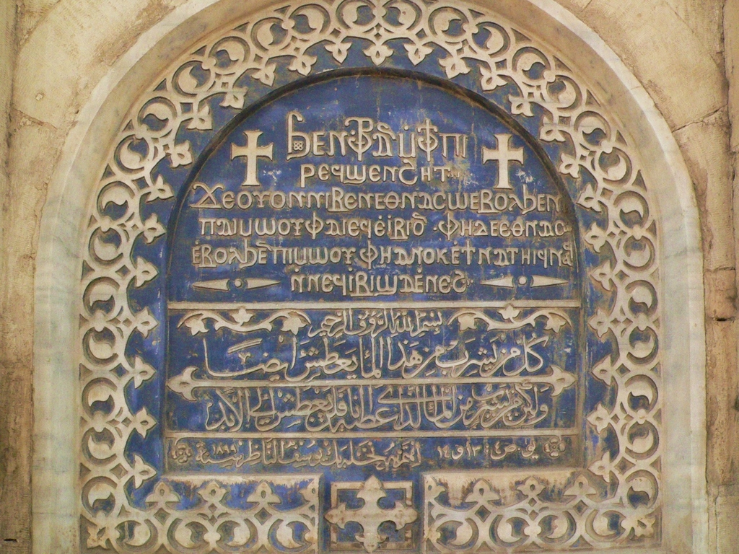

*This is on a church in Cairo: Coptic inscription of the Biblical verse on the top, Arabic on the bottom.Coptic & Arabic inscriptions Old Cairo, Egypt, photo taken April 2005. The verses are John 4:13 and 14. By Disdero, C.C.0, via Wikimedia Common*

For example, in Egypt, Arabic, Arab cultural practices and Islam, were not forced on Egyptians by the original Arab settlers and rulers. Egyptians, however, gradually became Arabic-speaking. Advantages could be gained from speaking Arabic and participating in Arab culture; jobs in government became possible, more favorable laws, and generally access to better opportunities came with both speaking Arabic and/or converting to Islam.

The Coptic Christians, however, remain a large community in Egypt (at least 10% of the population), and have preserved the language of Coptic, “an offshoot of Old Egyptian” (Versteegh,2001,p.15). The language is written in a form of Ancient Greek. Thus, they have preserved pre-Islamic cultural practices (Greek and Ancient Egyptian) through their liturgy and other traditions, although they speak Arabic as their mother tongue. Greek was the language of prestige during the Ptolemaic and Roman eras, which lasted for over a thousand years prior to Islamic rule. Old Egyptian, Greek, Arab, Turkish, and Persian (Persian empires also ruled briefly, and were hugely influential in the region as a whole) cultural influences are evident in Egyptian colloquial Arabic.

Early Islamic Expansion Under the First Four Caliphs

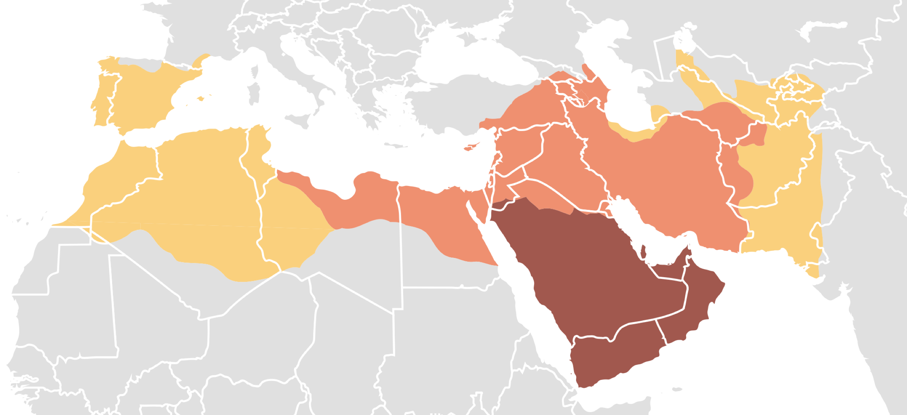

*“Expansion of Rashidun Caliphate” by DieBuche, C.C.0   Dark/Brown area: Expansion under the Prophet Muhammad, 622-632   Medium/Orange area: Expansion during the Rashidun, or “Rightly Guided” Caliphate (First Four Caliphs), 632-661   Light/Yellow area: Expansion during the Umayyad Caliphate, 661-750*

Early Islamic Expansion Timeline

622-632 – Islamic Empire under Mohammad. The early state began in Medina and gradually gained Mecca, Hunayn, Tabouk, and a large majority of the populated regions of the Arabian Peninsula. Abu Bakr, who ruled from 632 to 634, secured the entirety of the Peninsula and extended into present-day southern Iraq, Kuwait, Syria, Jordan, and Palestine.

634-644 – Islamic Empire under ‘Umar. The state then expanded dramatically under the leadership of ‘Umar. Lands claimed under his rule include the entirety of the Levant, most of modern Iran, slight expansion into present-day Turkmenistan, and entry into the northern coast of Africa in present-day Egypt and Libya.

644-656 – Islamic Empire under Uthman. The state extends slightly past the extent of ‘Umar’s rule. Modern-day south East Tunisia, most of Egypt, half of Afghanistan, and south West Pakistan were all brought under the Islamic rule. There was also increased incursion into south East Turkey and the Caucuses.

656-661 – Islamic Empire under Ali. The state experienced a decline due to the growing prominence of other emerging Islamic states, particularly the ‘Umayyad, and various factors of internal strife. The light sections of the map on Egypt and the Levant indicate the de facto leadership of Amr ibn al-As and Mu’awiya in each area. The dark green indicates the pre-existing eastern regions conquered under ‘Umar and ‘Uthman, with slight eastern expansion in modern-day Afghanistan and Pakistan, that Ali firmly controlled

# Chapter 5 Faith and Religious Identity

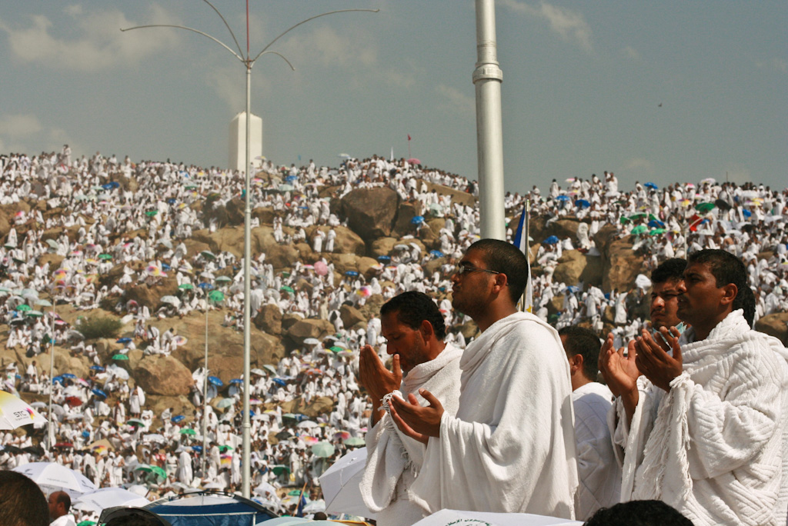

*Muslim pilgrims at Mt. Arafat, east of Mekka, in Saudi Arabia, for the Pilgrimage, or Haj. “Praying at Arafat” by Al Jazeera English is licensed under CC BY-SA 2.0*

This chapter looks at identity through the lens of religion. Religion was used for conquest, creating kingdoms and building empires in the region we now call the Middle East, and beyond. Religion has been and remains a powerful force in the Middle East, not just for members of one religious community, but as a cultural influence affecting everyone. We will provide an overview and comparison of the Abrahamic religions of Judaism, Christianity and Islam, and go into more detail about Islam. Zoroastrianism and the religion of Ancient Greece influenced those religions and have both had a major influence throughout the world.

## Sacred Places of the Middle East

Sacred Places Images: <https://ohiostate.pressbooks.pub/key2mideast/chapter/faith-and-religious-identity/>

Monotheistic religious beliefs are a major contribution of Middle Eastern peoples to the global religious picture, as well, considering that 55% of the world’s population profess one of the main monotheistic faiths (2.2 b. Christians; 1.6 b. Muslims; 14 million Jews). We refer to these faiths as the “Abrahamic Religions” in this chapter because they each trace their origins to the Hebrew prophet Abraham. All of these religions consider the Temple Mount in Jerusalem (image, right) to be central to their traditions and understanding of spirituality. We go into more detail about Islam because of the predominance of Muslims in the Middle East, the impact Islam has had on all members of society (including non-Muslims), and the need to correct pervasive stereotypes about Muslims.

The similarities across the Abrahamic religions and other religious groups can be attributed to shared histories, values and cultural practices. Historical ties between groups, shared literature, shared cultural practices and even shared prophets and kings. Cyrus the Great provides an example of religious tolerance from the Bible, while at the same time culturally and religiously diverse Islamic Empires exhibited strong cultural traditions that cut across those communities. Today the Middle East is defined by conflict and antagonism, but there are many shared worldview within these religions, in addition to the differences. This chapter provides examples of tolerance and pluralism from the Middle East, as well.

Acquiring knowledge about the religious diversity of the region is equally important. The following information is essential for gaining an understanding of the complexity of religious identity in the Middle East and the world. These identities go beyond the Abrahamic religions, encompassing Zoroastrianism, the religion of Bahai, and other religious minorities.  Yazidis (image, above), for example, are a religious group that has been prominently featured in the news recently, but which doesn’t fit neatly into the predominant religious categories (BBCb). Yazidis include Zoroastrian concepts in their theology. Zoroastrians are now a much smaller community, but they trace their history to the Persian civilizations of the past, and continue as a community today, although their numbers are dwindling. Their largest population is in India, and are known their as Parsis.

Religion has been a powerful social force in the region because, especially in the past, religious identity has been something closer to an ethnicity in the Middle East, defining one’s cultural identity as well as one’s spirituality. Religious-cultural identity has traditionally defined communities and their self-view. Regardless of the strong cultural group affiliation religious identity can entail in the Middle East, expressions of spirituality are not always from a single cultural standpoint. A diversity of religious perspectives, including secular or humanist ones, embrace both communal and individualized ways of understanding spirituality. Folk traditions are important aspects of religious practice within many of the societies in the region, as well as more monastic approaches. Sufism, for example, has been a path for many who have sought their own unique understanding of God, and we will explore about Sufism later in this chapter.

Minority religious communities have also often sustained their own means of legal arbitration and ways of approaching social institutions such as marriage and family. States often allowed these communities quite a bit of autonomy and the ability to apply their own rules, as long as they paid tribute to the state. The millet system of the Ottoman Empire is an example of that, which we discuss under the section “Islam in Middle Eastern Societies”. The millet system was also an acknowledgment of the legitimacy of Christianity and Judaism under Islamic law.

# Chapter 6 Diverse Religious Identities of the Middle East

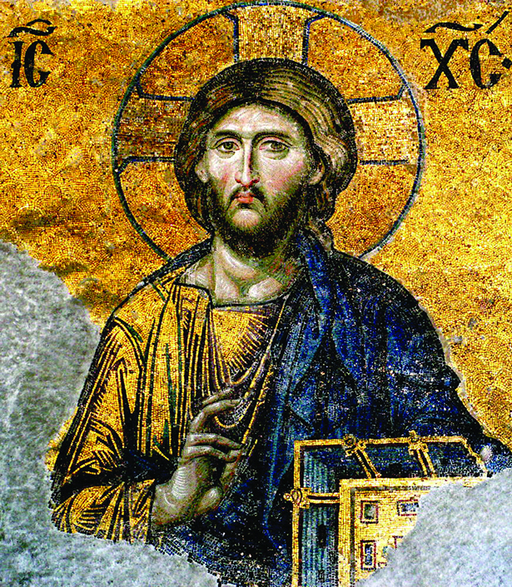

*Mosaic of Jesus Christ on one of the inner walls of the Hagia Sophia. “Christ Pantocrator (Deesis mosaic detail),” by Jembob. C.C.0, via Wikimedia Commons.*

The Middle East is perceived as predominantly “Islamic” due to the Muslim majority of the region’s population, but large numbers of non-Muslims reside there, and pre-Islamic influences remain significant. While it’s thought of as an Islamic region, the Eastern Orthodox Christian Church is a significant part of the region, for example. Its origins are rooted in Greek-speaking communities of the Eastern Mediterranean. Their split from Rome, what is now known as the Great Schism, was likely as related to the linguistic and cultural divide as much as to theological differences between the bishops of the Eastern Mediterranean and of the Western Mediterranean (Matejic, 2012).

This chapter therefore provides an overview of the predominant religions of the Middle East, including Islam, Judaism, Christianity, and Zoroastrianism, but there is significant diversity beyond these four religions. There are a number religious minorities, which may be sub-sets of a major religion, a case of religious syncretism, or something completely outside of those traditions.

## The Abrahamic Faiths

The monotheistic religions of Judaism, Christianity and Islam, are sometimes referred to as “Abrahamic Faiths” because of their shared heritage stemming from the patriarch, Abraham. Within these faiths there are many sub-categories, in addition to religious traditions of the region that came before Abraham, such as Zoroastrianism. Its founder, Zoroaster, was born in what is now Afghanistan, and the faith continues among a small number of adherents in Iran, India, and other parts of the world. Muslim and non-Muslim communities in Iran, Afghanistan, Pakistan, and Central Asian countries continue to practice its traditions alongside their religious practices. For example, marking the Spring Equinox in the festival of Now Ruz is a major traditional holiday in Iran, Afghanistan, Central Asia, and Pakistan.

There are general cultural aspects shared by Judaism, Christianity and Islam. They each:

* Were founded by a Semitic person or people;
* Refer to the same God: Yahweh in Hebrew; Jehovah in English; Allah in Arabic; Khuda in Persian.
* Use similar concepts of Justice. For example the idea that one should always consider God to be present when one is judging. Other than murder, adultery and stealing, bearing false witness was one of the most egregious crimes in the societies in which these religions originated.

Islam and Judaism have more doctrinal similarities with each other than they have with Christianity, especially in regard to their concepts of monotheism (God being without offspring or partner – this is a specific reference to Surat al-Ikhlas of the Qur’an in Islam – ), their legal systems and in their rigorous restrictions on daily life and practice, such as their protocols for diet. However, unlike Judaism, both Islam and Christianity are universal religions; i.e., one needn’t be born into it to participate in the religion. The following religious comparison grid provides key areas of similarity and difference amongst them.

Abrahamic Religions Comparison Chart

|  |  |  |  |
| --- | --- | --- | --- |
| Belief/Practice | Judaism | Christianity | Islam |
| Concept of God, monotheism | One god, considered as creator and sustainer of the universe. Worship of any additional gods is discouraged by banning images of humans and animals which could potentially be idols. | One god, considered as creator and sustainer of the universe. God as cause of Mary’s immaculate conception, and “father” of Jesus. | One god, considered as creator and sustainer of the universe. God possesses no partner, no offspring. Worship of any additional gods, or idols, is strictly forbidden. Worship of any additional gods is discouraged by banning images of humans and animals which could potentially be idols. |
| Messengers of God/Prophets | Belief in prophets of God. | Belief in prophets of God. Jesus is considered the Son of God. | Belief in prophets of God. Belief that Muhammad is the last of God’s prophets. Jesus is considered a prophet. |
| Timing for weekly worship/community gathering. | This is a day of rest,  Friday evening through Saturday evening is a time of required rest from normal daily work. Synagogue services on Saturday are a time designated for community. | This is a day of rest, Community worship on Sunday. It is a required day of rest from normal daily work. | Friday is the day for group prayer.  Work is allowed, however. |
| Scripture | Torah (including the Ten Commandments). | Torah (including the Ten Commandments); New Testament. | Torah (including the Ten Commandments); Psalms; Gospels of the Christian Bible; Qur’an |
| Afterlife/eschatology | Judgment Day, Hereafter | Judgement Day, Hereafter | Judgment Day, Hereafter, Heaven, Hell, Purgatory, Limbo |
| Stories of Human Origin | Adam and Eve as the first humans; the great flood; | Adam and Eve as the first humans; the great flood; | Adam and Eve as the first humans; the great flood; |
| Alms | Tithing, or giving a portion of your wealth to those in need. | Tithing, or giving a portion of your ealth to those in need. | Alms, or Zaka, is one of the five pillars |
| Circumcision | Required for males. | Not required. | Required for males. |
| Pilgrimage | Was required, until the temple in Jerusalem was destroyed. | not required. many pilgrimage sites, however. | required to Mekka. tombs and shrines that may also pilgrimage sites. |
| Ritual Use of Water | Ablutions before prayer, and traditionally before entering the Temple in Jerusalem. | Holy water is used before entering a church, to bless worshipers during mass, and to baptize. | Ablutions are required before prayer. |
| Messianic expectations | The king will one day return. | Jesus will return on Judgment day | Shi’is expect the rightly-guided Imam, or Mahdi, to return. |
| Supernatural entities | Angels | Angels, Satan/Lucifer | Angels, Jinn, Satan, or Shaytan/Iblis |
| Fasting and Dietary restrictions | Fasting for Yom Kippur.  Multiple restrictions and requirements for preparation, including the way to slaughter animals. No pork. Ritual use of alcohol. | Fasting for lent. Eastern Orthodox Christianity requires a vegetarian diet for lent.  Pork is allowed. Ritual use of alcohol. | Fasting for Ramadan. Multiple restrictions and requirements for preparation, including the way to slaughter animals. No pork. No alcohol. |

# Chapter 7 Religious Diversity

Within each of these religions there is immense diversity. For example, many don’t know how diverse the state of Israel is in reality. Not only Jewish, Israeli citizens can be Muslim, Druze or Christian. They can be Arab, in addition to Jews of every ethnic heritage both in Israel and around the world. In general, Jews with European heritage are called Ashkenazi Jews, while Jews from the Middle East are called Sephardic Jews, or *Mizrachim*. The diversity is hardly limited to those two categories, however. Individuals from every continent and cultural background make up the population. Core tenets from the Torah are shared by all Jewish communities, but the practices surrounding them vary from community to community.

Likewise, there is much diversity within Muslim-majority countries, and within the global Muslim population as a whole. Several communities follow religious practices which emphasize different aspects than mainstream Islam, have separated into a theology, or combine theologies with other religions:

* ‘Alawi Shi’ism: a form of Shi’ism, but more centered on venerating ‘Ali. There are many communities in Syria and Turkey (Bashar al-Assad, the President of Syria, is an ‘Alawite)
* The Druze Faith: Islamic foundation, but radically different practices and theology
* The Bahai’ Faith: Related to Shi’i Islam, recognizing a prophet who came after Muhammad, however.
* Yazidism; Combination of Islam, Zoroastrian and other traditions.

These facets of diversity show how many minority groups there are, and have been, in the Middle East, and how problematic it can be to generalize about the religious outlook of a country, or even a small area within a country. In the U.S. and other countries around the world, many Middle Eastern immigrants represent minority communities of the Middle East (see image gallery, left, of celebrities with diverse Middle Eastern religious and cultural identities).

The minority communities of Jews and Christians used to be a much larger percentage in most of the countries of the Middle East.  Post-World War I European interventions often had the effect of concentrating ethnic-religious groups into specific countries.  For example, the Greek Christian/Muslim Greek population exchange of 1923, which was a continuation of the Christian/Muslim migrations that resulted from the Greek/Turkish war.  At the same time, war devastated many other communities who were expelled, such as the Armenians.  These trends intensified as nation states developed out of prior colonies/mandates, and other territories impacted by European imperialism.

The violent demographic shifts that occurred in the Middle East over the course of the 20th century created, and continue to create many new Middle Eastern diaspora communities worldwide. The effect has been dwindling minorities in countries which lost much of these populations, and the underrepresentation of nations which did not succeed in forming a nation-state country of their their own. The Kurds a currently in the headlines as a prominent stateless nation, and a community/ies with complicated relationships with the governments Turkey, Syria, Iraq and Iran, where Kurds reside.

The creation of Israel was another influence on the demographic make-up of the Middle East. It drew large Jewish populations from many of the Middle Eastern countries, especially Morocco, Yemen, and Iran. Other countries were affected, as well. Jewish communities remain in those countries, but their numbers are severely diminished. For example, Afghanistan used to have a thriving Jewish population, but there is now only one remaining Jewish resident of the country (Englehart,2009).

Christian communities in Middle Eastern countries are perhaps the least represented communities in mainstream information sources. Assyrians, Armenians, Copts, and other cultural groups that are predominantly Christian, are increasingly minoritized in Muslim-majority countries while at the same time many of their communities in diaspora. Only Armenians have their own nation-state. At the same time, they are more prominent here in the U.S., where we are writing this book, because communities make up a larger percentage of the total number of individuals who have emigrated from the Middle East to the U.S., than do Muslims. Therefore, it is more likely for one to meet a Christian with Middle Eastern heritage in the U.S. than in the region.

# Chapter 8 Islam in Middle Eastern Societies

The Muslim populations of the Middle East make up only 44% of the total world Muslim population of the world (see “Muslim-Majority Countries of the Middle East” chart).  A basis for understanding the role of Islam in Middle Eastern societies, is the distinction between its doctrine and the cultural practices which are done in the name of Islam or which informed them, historically. An effective way to bring out contrasts is to compare Islam with Judaism and Christianity. At the same time there are many aspects they share which are rooted in the same cultural milieu. We recommend reviewing the comparison chart comparing the Abrahamic religions again after reading this section.

In Islam, as in Christianity and Judaism before it, there are two distinct realms for religious oversight:

* faith and worship (*ibadat*).
* temporal and worldly activity (*mu’amilat*).

Islamic law, or the *shar‘ia*, is a system of theological exegesis and jurisprudence which covers both areas. Thus it guides the religious practices of Muslim communities, and also may serve as a basis for government as it did in Islamic empires of the past and a handful Muslim states of the present, such as Saudi Arabia. Once the modern nation state became the norm for government in most Muslim-majority countries *shar ‘ia* took a different kind of role in Muslim society, as states favored Western-style government and constitutional democracy. Secular states encouraged a more private practice of Islam.

Shar’ia remains an important guide to daily life for many Muslims, but its legislation now resides outside of the legal system in most Muslim-majority countries, with differing levels of involvement and influence. In some cases shar‘ia has remained the state’s government and legal system, as in Saudi Arabia. In any Muslim community, however, Islam’s precepts for good conduct remain paramount. The Five Pillars provide a foundation for proper religious practice, and are as follows (in order of importance):

1. *Shahada*, or Declaration of Faith;
2. *Salat*, or Prayer (5 times daily);
3. *Saum*, or Fasting (Especially During the Month of  Ramadan);
4. *Zakat*, or Alms (2.5% of one’s income should go to those  in need, provided one has that much after meeting one’s own, one’s immediate family, and surrounding community needs);
5. *Ḥaj*, or Pilgrimage (if one has the health and financial means, a Muslim is required to go to Mekka once in his or her lifetime, during the month of *Ḥaj* and perform a specific set of rituals).

In Islam, the only requirement to become Muslim is the first pillar; which is simply to utter the *Shahada*, or Declaration of Faith (translation, Payind): “I bear witness that there is no God other than the one God. I bear witness that Muhammad is the servant messenger of God.”

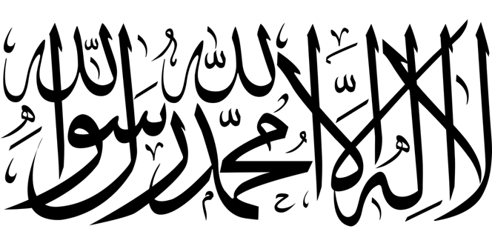

*Image of the Shahada in Arabic Calligraphy, from Pixabay, CC0*

Beyond the Five Pillars, however, a moral life includes principles from the Qur’an and the example set by the prophet Muhammad which provide a moral foundation for the practices and laws which are intended to guide all facets of individual lives, families and society as a whole.

## The Concept of Jihad

These principles for leading a correct life often require a moral struggle to achieve. This relates to a duty in Islam called *jihad*. The meaning of *jihad* is struggle – it can be internal and spiritual/moral, or external and physical/combat. Inner struggle is considered the “Greater *Jihad*”, or *Jihad al-Akbar*, due to its greater difficulty and greater importance in the life of a Muslim. *Jihad al-Akbar* is revered by Muslims. *Jihad’s* other meaning, related to war against an enemy, is the lesser jihad, or jihad al-Asghar. This is the struggle against injustice, oppression or *invasion*, and it allows the use of military force. *Jihad al-Asghar* possesses greater renown in the West, due to three powerful factors:

* Jihadi extremist groups in the news,
* European conflicts between Europe and what they called “Islamdom”, termed “Holy War” at the time (*jihad* continues to be translated as “holy war” for this reason).
* Stereotypes of Muslims as angry and violent aggressors pervade the Western knowledge base due to this history and the reinforcement of these images through various forms of media.

This list reflects the association which has developed in Western cultures between Islam and violence. Theologically, Islam’s orientation toward war is to minimize, and consider it as a last resort. The Qur’an expressly forbids needless killing:

“Because of this did We ordain unto the children of Israel that if anyone slays a human being-unless it be [in punishment] for murder or for spreading corruption on earth-it shall be as though he had slain all mankind; whereas, if anyone saves a life, it shall be as though he had saved the lives of all mankind. “ Qur’an, Surah 5, Verse 32, Pickthall translation

Islam doesn’t condone a passivist response to violence or injustice either. In this aspect, it differs greatly from Christianity’s precept to “offer the other cheek”. According to *shar’ia*, retaliation is acceptable, provided that it is and arbitrated decision, based on evidence, and it falls under one or more of the following categories:

* self defense.
* a response to an assailant of your family or community.
* apostasy, or treason (apostasy, or the relinquishing of the faith, has traditionally been considered a form of treason).

# Chapter 9 What is Shar'ia Law?

Islamic law, or *shar‘ia*, is based on a set of sophisticated legal systems, and provides a basis for government as well as for personal life. The processes of developing *shar‘ia* are based on strict standards. Religious legal interpretation, or *fiqh*, encompasses nearly every permutation of social structure, area of human activity and aspect of government.  The *usul al-Fiqh* are the sources of Islamic legal interpretation.  These sources are used according the sequence below:

1. The Qur’an
2. The Traditions of the Prophet, *the Sunna,* his words (*Hadith*) and actions, or entirety of the traditions (*Sunna*)
3. Consensus of Juridical Scholars, or *Ijmaʿ*
4. Analogy by Deduction, or *Qiyas*
5. Process of Setting New Precedents Based on the Above Sources, *Ijtihad*

There is a misconception that *shar‘ia* is taken directly from the Qur’an without any process of interpretation, or application of legal precedents. The Qu’ran is the most important source, and must be looked to first, but it is not the only source. Islamic jurisprudence, or *fiqh*, considers five main sources to be valid authorities. The first, and most authoritative is the Qur’an, which is considered the word of God. The Qur’an, however, did not address every particular aspect of daily life, but mainly gave principles to live by. Thus, accounts of the prophet (*hadith*) Muhammad’s life and quotes of his words are the second most important source. In more complicated matters, the scholar can refer to the consensus of his peers. Jurist scholars then use analogies (*qiyasat*) when the exact case they are considering is not mentioned in these sources. For example, drugs like crack or heroin are not mentioned, but the prohibition on alcohol is issued due to its effect on the judgment and perception. This is a clear analogy the judge can use. Finally, if there is no precedent, he or she must engage in the intellectual struggle of *Ijtihad*. *Ijtihad* is based on the same root as *jihad* (which means to struggle – refer to “The Concept of Jihad” for more details), indicating the level of effort required for identifying new paths for new circumstances that remain true to God’s will.

Religious legal interpretation, or *fiqh*, encompasses nearly every social structure, area of human activity and aspect of government. There is a massive body of law from which scholars of Islamic jurisprudence may draw upon. The Sunni schools of thought, or *mudhahib*, are: Hanafi, Maliki, Shafi‘i, and Hanbali, while the primary Shi‘i school of thought is Ja‘afari. Among the Sunni schools of thought, Hanbali, is the one with the most focus on purifying Islam and adhering to the Qur’an and the Sunna. This is the basis of Wahhabism and relates to the *salafi* movement that we explain more in subsequent sections. See [Wikipedia’s map of *mudhahib* distribution](https://upload.wikimedia.org/wikipedia/commons/4/44/Madhhab_Map3.png) to understand what the countries of the Middle East and other Muslim-majority regions adhere to in regard to these schools of thought in Islamic legal interpretation.

# Chapter 10 Religious Pluralism

Islamic states also tolerated religious laws of non-Muslim communities, considered a “people of the book” or *ahl al-kitab*. The concept of tolerated religious communities is called *Dhimma* in Islamic law, and the communities are therefore called *Dhimmi*. Under Islamic law, states had to recognize these religious communities because they are sanctioned by the Qur’an. Because their prophets and scriptures are recognized in Islamic law, ahl al-Kitab were allowed to continue their religious and communal functions within the larger social and legal contexts. At the same time they had different rights and obligations than their Muslim counterparts. For example, the *jizya* was a tax for *Dhimmi*. *Dhimmi* were also exempt from military service, however, and did not pay the alms that Muslims were expected to pay, somewhat leveling the balance of obligation between Muslims and non-Muslims.

The Ottoman Empire is example of an example of an Islamic state which governed according to the precept of *Dhimma*. *Dhimmi* were called *millet*. The word *millet* means religion or religious community, but it can also be translated as nation due to affinity between ethnicity and religious identity at the time. The *millet* operated under the rules of the *Dhimma* mentioned in the previous paragraphs, and maintained thriving communities in all the major cities of the empire. The Ottoman Empire is often recognized for its achievement of pluralistic governance because of this, although the minorities also faced some level of discrimination. Armenian Christians are one such community, which was displaced after the Turkish war of independence and the end of the Ottoman Empire.

On the other hand, a great example of religious tolerance also comes from the Middle East.  The Biblical story and centers on the figure of Cyrus the Great, the King of the Persian Empire. The Bible says of Persian Achaemenian King, Cyrus, The Great:

‘So said the Lord to His anointed one, to Cyrus’

—Isaiah, Isa 45:1-7, quoted in the Wikipedia Entry “Cyrus the Great”

In Jewish culture at that time, “anointed one” was a term reserved for kings. To anoint someone ceremonially was to make him king. This indicates their acknowledgment of Cyrus’s role in saving their community from Babylonian persecution. Cyrus the Great, c. 600 or 576 – 530 B.C. (Dandamaey,1989) conquered a major expanse of territory during his reign, but he also gained a reputation for benevolence. As leader of the Achaemenian Empire, he instituted pluralism in his religiously and culturally diverse empire.

# Chapter 11 Prayer, A Part of Daily Life for Muslims Around the World

Daily life in Muslim-majority regions varies greatly, but there are some universal experiences based on the practices required by s*har’ia*. One of them is prayer, although its practice varies amongst individuals, communities and whether the setting is urban or rural, and the degree to which local laws and practices are Western in orientation.  Certain aspects are very common. In most Muslim-majority contexts, for example, Muslims hear the call to prayer from their windows five times a day. To an outsider, this may seem like a burden for Muslims, but to an insider it is an accepted norm.  It may be considered as a way to set the pace of life and maintain orderly work and social patterns, especially in traditional areas. Each prayer has a practical function in addition to its spiritual function:

* Morning, or *Fajar*, the prayer just before dawn encourages an early start to the work day.
* Mid-day, or *Dhuhur*, is a short prayer at mid-day to ensure a break is taken from work (and implies work should be engaged in all morning).
* Pre-sunset, or *‘Asr*, is another short prayer to ensure another break, and a healthy pace of work.
* Post-sunset, or *Maghrib*, prayer takes place just after sunset, and indicates a time of day when one can retire and be with family and community.
* Evening, or *‘Isha’*, is the final prayer, which takes place in the evening and signals it is almost time for bed.

Daily prayer is universal in Muslim communities because it is one of the five requirements all Muslims must observe, or the Five Pillars.  It isn’t necessary to pray in a Mosque, or even a private area. The only requirement is that the space be clean.  This is the purpose of the prayer rug.

Image Gallery, Expressions of Muslim Prayer: <https://ohiostate.pressbooks.pub/key2mideast/chapter/daily-life-for-muslims-around-the-world/>

# Chapter 12 Shi'ism

The word Shi‘i, also referred to as Shi‘ite, means “one who is a partisan,” or “supporter”, in Arabic. It is in reference to ‘Ali, prophet Muhammad’s cousin and son-in-law, who many considered his rightful successor. This partisanship dates back to just after the death of the prophet in 632, C.E., when there was disagreement over who should be his successor. A meeting was convened, and the prophet’s friend Abu Bakr was chosen by the group. Those who agree with that decision call themselves followers of the traditions, or Sunna, of Islam. They are thus called Sunnis. The differences between Shi‘i and Sunni Muslims are primarily focused on this history, and not as much on doctrine. There are a lot of theological similarities between Shi‘is and Sunnis – more than one might expect, considering their historical disagreements, and they are as follows:

* Both follow the Five Pillars.
* The Qur’an is the same, word for word.
* Prayer is the same; i.e., times of day, same direction, etc. (Some minor differences are that Sunnis fold their arms when they pray, while Shi’i let them hang. Some Shi‘i *Muadhans*, those who call the community to prayer, add the phrase *‘Ali Wali Ullah*, or ‘Ali is the Viceroy of God, at the end of *Adhan*, or the call to prayer.)

Shi’i Leadership Genealogy:



Shi‘is have also been called *Fatimis*, or Fatimids (during their reign in Egypt), because they regard the lineage through prophet Muhammad’s daughter, Fatima who married ‘Ali, to be the valid transfer of power. They do not consider the first three successors of the prophet recognized by Sunnis to be valid. This is their fundamental disagreement with Sunni Muslims.

Shi’is emphasize the value of lineage and family ties over the consensus of a large number of Muslims after the Prophet’s death. This value is reflected among the *Ja‘afari* Shi‘i, who follow a tradition of wearing a black turban to indicate one’s lineage traces back to the Prophet. Both Sunnis and Shi‘is respect the descendants of the Prophet, however, and call them noble, or *Sayyids* or *Sherifs*, in Arabic.

The political doctrine of the Shi‘i recognizes the institution of the Imamate, or Imama, as head of state or community. According to this doctrine, the leader of a Muslim community, or the Imam, must be a direct descendent of Prophet Muhammad through his daughter, Fatima, and son-in-law, ‘Ali, as the head of government. On the other hand, the political doctrine of the Sunni is the Caliphate, or *Khilafa*, as the head. This reflects the political process that occurred after the death of the Prophet in 632 to select the leader by traditional tribal meeting, or *shura*. A *shura* was convened, and Abu Bakr was chosen by the participants of that meeting through *bay‘a*, which means group decision by consensus.

Eventually, ‘Ali was elected leader, but he was killed by the hand of a secessionist, or Khariji, rebel in 661. After that time, the Sunni Muslim community reverted to dynastic rule, the prior paradigm of the Arab communities of Mekka. Mu‘awiyya established the superiority of his clan, the ‘Umayyids, and they ruled the umma, or significant portions of it, for another 370 years. Thus, the Caliphate became more like the institution of monarchy thereafter.

Hussayn, ‘Ali’s grandson, made a claim as the rightful leader, finally dying at the Battle of Karbala in 680. After that, the lineage continued, with claims on the Imamate, but there were contestations (see chart, p.37). Two of Ja‘afar’s sons claimed to be Imams – one was Isma‘il. The followers of him are the Isma‘ilis, or the Seveners, who reside in Pakistan, North Africa, Central Asia, including North East Afghanistan, and the mountains of Tajikistan. They recognize a living Imam, Karim Ali Khan, or Karim Agha Khan. Thus, in Afghanistan and other Central and South Asian countries, they are also sometimes called Aghakhanis.

In 874 Muntazar, the 12th Imam, disappeared. His followers, the Twelvers, consider him to be the rightful Imam, and expect he will return. Because of this they are often called Imami Shi‘i. In the absence of the 12th Imam, Shi‘i argue that their jurist scholars, or *Mujtahids*, should fill the position of Imam. This would be a temporary form of leadership until the reappearance of the 12th Imam.

# Chapter 13 The Mystical Tradition of Sufism, or *Tasawwuf*

There is a lot of press given to Sufism these days, focusing on its moderate and inclusive political affiliations and promoting it as a paradigm of ecumenical tolerance and spiritual transcendence. One example of this is the worldwide popularity of Rumi.  He was cited as the best-selling poet in the U.S. in 2014 (BBC – <http://www.bbc.com/culture/story/20140414-americas-best-selling-poet)>.  It is largely due to Rumi, in fact, that Sufism provides such potent imagery and ideas and has captured the Western popular imagination.

Image Gallery, Legendary Sufi and Mystic, Maulana Jallaluddin Rumi Balkhi:

<https://ohiostate.pressbooks.pub/key2mideast/chapter/the-mystical-tradition-of-sufism-or-tasawwuf/#rumi>

Sufism consists of much more than the order founded by Rumi, of course, and its practices are as diverse as the regions in which it thrives. From West and North Africa, to Turkey, Iran, Afghanistan, and Central Asia, Sufism has many interfaces with the practices of average people and mystics alike. These include the maintenance and visitation to shrines and tombs of deceased saints, Islamic endowments, or *waqfs*, buildings intended for Sufi practice, and the passing on of the traditions. Many daily expressions have also derived from Sufism, which has contributed to sayings, references, concepts in literature and popular culture.

Mysticism is a thread that runs through all three of the Abrahamic religions. Sunni and Shi’i individuals and communities have adopted mystical paths of Sufism throughout the history of Islam. Sufism, or in Arabic, *tasawwuf*, is an umbrella term which refers to the inner mystical dimension of Islam. The same linguistic root also generates from the word for wool in Arabic; hence, a Sufi is one who wears a wool, or *suf*, garment. This refers to the practice of some ascetic mystics who would wear a simple wool garment. The word in Persian for those who wear wool is “Pashmina Push”, a common reference in Sufi poetry. Sufism has a highly diverse set of traditions, with adherents from many different walks of life and with different levels of involvement.

Mystics were among the prophet’s companions and the earliest Muslims, before Orthodox Islam was established. They supported an inner path which harmonized inner spiritual life while also maintaining religious codes for daily life. For Sufis, the universe, with all of its seemingly complex entities, forms a unified whole, bound together by love. The messages of Sufi thinkers reflect the universal and inclusive nature of Sufism. This is one such example (Interpretation by Coleman Barks, n.d. – rephrased by Payind):

Only Breath

–Maulana Jallaluddin Balkhi Rumi

There is a breath of God in each of us human beings.

Neither Christian, nor Jew, nor Hindu, nor Buddhist, nor Sufi, nor Zen.

Not any religion or cultural system.

I am not from the East or the West.

Not out of the ocean or up from the ground,

not natural or ethereal, not composed of elements at all.

I do not exist, am not an entity in this world or the next. I did not descend from Adam and Eve, or any origins story. My place is placeless, my trace is traceless. Neither body, nor soul.

I belong to the beloved, have seen the two worlds as one. And it is that one I call to, and know first, last. . .inner, outer. Only that breath, breathing the human being.

Maulana Jallaludin Balkhi Rumi, or simply Rumi, as he is known in the West, was a pious Muslim, a mystic, a scholar of Shar’ia law and a famous poet who lived in the 13th century. He was born in Balkh, in what is now Afghanistan, but his family moved to Konya when he was a boy, in what is now Turkey. Muslim mystics have made substantial contributions to the world’s mystical literature. This is especially true in regard to Rumi, but also in regard to Al-Ghazali in the 12th Century, and Hafiz in the 14th.

Beyond the image of inclusivity, there is a counter-cultural aspect of Sufism, as well. Sufi mystics often lived life on the margins of society and went against what they regarded as petty cultural norms. Many of them were ascetics who wore austere clothing, such as the aforementioned rough wool garments. It is not correct to define Sufism as simply a counter-cultural phenomenon, however. It has always been and continues to be an integral part of mainstream Islam. According to Islamic theologians, the religion is intended to be practiced, both in regard to inner life, and in accordance with outward prescriptions for living life in compliance with God’s will.

Sufism’s mainstream aspect is also confirmed by the fact that it is still considered to be a path to spiritual enlightenment by many in the Muslim world, and that it has been responsible for much of the conversion in the Muslim world. It has become intertwined with local traditions and folk practices of Islam, which often reflect certain pre-Islamic traditions of the area. Its inclusive nature, and its focus on the Qur’an as the primary source for religious interpretation, creates a more flexible and open stance toward other religious frameworks which may be seen as having emerged from the same source, the one God, or Allah.

# Chapter 14 Who are the Salafis/Wahabis?

Amongst the Hanbalis, there is a well-known movement called the Salafi movement. One of the most well-known Salafi groups are the wahabis, a movement with its origins in Saudi Arabia. Wahabis are vehemently against tomb worship, and many of the folk practices of Islam that have been tied to Sufism and/or reverence for particular mystics and holy men (often referred to as *walis* in Arabic).  According to Hanbal’s Islamic theology, these practices are seen as a form of idol worship, defined as a partnering of mortal human beings with God. This is fundamentally in contradiction with one of the main tenets of Islam: monotheism, or *tawhῑd*.

*Salaf* means ancestors, and the Salafis, or followers of the Salaf, believe that the spiritual and temporal practices of the earliest Muslims and companions of the prophet provide a comprehensive guide for current-day life and government. Muslim intellectuals of the 19th and early 20th century, grappling with the prospect of modernization and Westernization, saw much potential in this approach because of the universal principles contained in the Qur’an, the prophet’s words and the way he and his companions conducted themselves. The ideal was that they would find a way to adopt Western technology and institutions while applying Islamic concepts to how they would be adopted. As the movement progressed, however, it became more of a fundamentalist movement, and currently one hears about Salafis in the news primarily in connection to radicalization.

# Chapter 16 The Middle East and the Impact of Imperialism

After the First World War, the contours of the major nation-states of today’s Middle East were delineated.  The Paris Peace Conference of 1919 solidified the political boundaries that later became the countries of the Middle East. At the same time a movement to recognize the sovereignty of colonized countries let to the creation of mandates based on the territories ruled by European countries, with the idea that they would develop toward independent status.

Many promises were left unfulfilled, however, as cultural communities such as the Kurds were left with no territory of their own. To this day, the Kurds are a “stateless nation”, with their territory spanning across 4 nation-states: Turkey, Syria, Iraq and Iran (see map, below). We cover the concept of a stateless nation and provide other examples in this chapter as part of a discussion on the national identities of the Middle East of today.

Map of Kurdish Territory by the CIA

# Chapter 17 Defining the Term “Middle East”

Culturally-speaking, it is difficult to limit the Middle East to a geographic area with hard borders. Civilizations outside of what is commonly referred to as the “Middle East” made intellectual, cultural and biological imprints in today’s Middle East that are indelible, especially in regard to the waves of migration from Central Asia. Further, North Africa has profound cultural connections through language, religious practices and philosophical discourses. There have been contiguous flows of thought and ideas, whether through the spiritual content of Sufism and Muslim folk practices, or through practices and technologies of law, medicine, education, and food production.

With the exception of Israel, the countries in our definition span from North Africa to Central Asia, and are Muslim-majority countries with large populations speaking one or more of the major Middle Eastern languages (Chapter One). Historically, there have been many definitions, however, which do not correspond to our definition closely, if at all (Center, F. G. E.a). Currently, West Asia, from about the Amu Darya (Oxus) River westward, North Africa, and often Turkey, are usually considered a part of the region. Our definition is one of the more inclusive ones because of the shared languages and may shared religious and cultural practices within the countries listed in the introduction.

In 1902 the term “Middle East” was coined in order to designate the area residing between Egypt and Singapore, comprising major access points to Asia, such as the Suez Canal, the Red Sea, the Persian Gulf, etc. ([Center, F.G.E.c](http://www.unc.edu/mideast/where/chirol-1903.shtml)).  West Asia, where most of the countries of the Middle East reside, used to be called the “Near East”, but the newer term “Middle East” also came into usage in the early part of the 20th century.

The main purpose for covering these definitions in this chapter is to demonstrate that the bases for any of the most commonly used terms, also including “Orient” and simply “the East”, are rooted in European perspectives. These terms center Europe in the geography of the world map.   Thus, geographic definitions tended to refer to strategic lands which provided Europeans with access to resources and military advantage, especially India ([Center, F.G.E.b](http://www.unc.edu/mideast/where/mahan-1902.shtml)).

# Chapter 18 National Borders as Foreign Intervention

As some of our students have observed in class, there is a predominance of straight borders on the Middle Eastern map. The national boundaries on the map of the Middle East and North Africa greatly oversimplify, or actually erase, many of the linguistic and cultural identities of the Middle East. This is because the borders were only based in part on local ideas, always formed in negotiation with European decision-makers. Some of them were almost entirely imposed from the outside. The examples of Jordan and Kuwait illustrate this:

“During a five day conference in 1922 at Uqair in Eastern Saudi Arabia Sir Percy persuaded Arabia’s future monarch, Ibn Saud, to recognize Iraq. . and determined Iraq’s borders with Kuwait and the Nejd.” Kingmakers, p. 188

“Taking out a map and a pencil, Cox drew the boundary between Iraq and the Nejd. The borders with Syria and the Transjordan were penned similarly. . The International Boundary Commission. . .” p. 189

“Winston Churchill, then British Colonial Secretary, allegedly claimed that he created the borders for the British mandate Transjordan, roughly modern-day Jordan, ‘with the stroke of a pen’ one Sunday afternoon in Cairo.’” (Diener, 2010, p.189)

The term “Middle East” reflects a European worldview, originally imposed on the Middle East through colonization. This is why, if you decide to study the Middle East further or visit there, you may encounter conflicting geographical definitions.  Often the term “Middle East” is employed, while at the same time some may choose to speak about their country as part of “West Asia,” “North Africa,” or even “Europe” (in the case of Turkey). It is important to be aware of the political connotations of the various terms.

It is misleading that “The West” came to refer to anything of European cultural origin, in contrast with any other community worldwide (not exclusively “the East”). This binary often, but not accurately, is associated with the axes of “First World” and “Third World,” “Developed” and “Developing,” etc.  The line between European/European settler states that were much more modern, or “developed”, and all the other countries of the world, is no longer valid, however. Global health scholar, Hans Rosling, has culled USAID statistic since the 1950s which show that, while there once was a gap, in the past 60 odd years lifestyles have become increasingly similar (2009).

# Chapter 19 The Impact of Imperialism on the Region

“Everybody did empire.”

-Niall Ferguson, 2011

Imperialism was nothing new in the world when European expansion began impacting the Middle East. As Ferguson said, “everybody did empire” (2011). It’s important to distinguish, however, between imperialism as it was “done” in antiquity and medieval times, and its modern form. Political developments in Europe, such as the Magna Carta, and the Treaty of Westphalia, followed by economic transformation from global trade and industrialization led to a completely different form of imperial power. Europeans brought their ideas, institutions and technical inventions with them, and many of them became standards for the whole world.

There are many terms for the uneven power relationships which developed between European states and the area we know as the Middle East today. This chapter discusses these power relationships and their importance for the Middle East. The term “imperialism” can be a “catch-all” to describe the relationship between a powerful country with a less powerful country. Rather than compete with other ways of using the term, and perhaps furthering the confusion surrounding its usage, we use “imperial dynamics” in this chapter. At the same time there is a classical meaning for empire, with reference to the empires of antiquity such as the Greeks and Romans.

When economic historian Niall Ferguson says “everybody did empire” he is de-emphasizing the power European empires had over the rest of the world. In fact, European settler colonialism made a major global impact, evidenced by the ubiquitous European linguistic, cultural and institutional practices found worldwide and in global systems. The English language we are using to write this book, for example. This imperialism has been experienced as global dominance by colonized countries, and especially by indigenous cultural communities. Ferguson admits that certain institutions (2011), developed and established globally via European colonialism, must be internalized by countries worldwide attempting to gain equal footing in global affairs and financial systems.

In the Middle East, there have been varying degrees of interference by outside powers. Not all countries of the Middle East were colonized: Turkey, Saudi Arabia, Iran and Afghanistan remained sovereign. Algeria illustrates another end of the spectrum. It was considered by France, not as a “colony” but as part of France proper. Similarly, the Belgian King Leopold II considered Congo his personal possession.

Countries were at times defined in more independent terms, although they remained under the control of foreign government. For example, “protectorates” were territories endowed with semi-autonomous government. The Sultanate of Egypt (1914-1919) was one of those, a short-lived protectorate of the British Empire. A local king was placed in power, but the purpose was mainly to sever it from the Ottoman Empire during World War I (L.O.C., Egypt). This was before the League of Nations and the Mandate System, which codified an international policy of gradual self-rule for colonized countries.

Due to these varying levels of sovereignty, and the fact that even countries which were not actually colonized had to contend with European power, “colonial dynamics” refers to the varying levels of influence and power European countries have had over Middle Eastern countries. The era of “imperial dynamics” starts roughly with “The Great Game”, between Britain and Russia during the 19th century. This refers to their competition over territory between Russia and the Indian subcontinent. Russia was seeking access to a warm water port, while Britain was seeking access to its most valuable colony, India. The Middle East was the arena for this struggle.

The era of colonialism is often placed in the past, but for many colonized groups, its effects are ongoing. Formal imperialism, with direct control of colonies around the world, and the ability to implement imperial policy from the “mother country”, has been curtailed since roughly mid 20th century when the Bandung conference of 1955 (p.57) was convened by colonized countries. Powerful countries continue to have the power to set the standards for participation in global economics and political affairs that less powerful countries must follow, however. Furthermore, indigenous groups in many Western countries continue to protest ongoing colonialism that affects their communities, as protests in the Middle East also often portray Western countries as imperialists.

An example of Western dominance seen as imperialism in the Middle East is the case of Dr. Muhammad Mossadegh, who was prime minister of Iran. In 1953 he was duly elected but was forcibly removed by British intelligence, and the U.S. CIA. Subsequently, Muhammad Reza Shah Pahlavi (son of Reza) was put on the throne, and the CIA trained his notoriously brutal secret service, *Sazeman e Et-tela va Aminiyat e Keshvar* (SAVAK).This background information helps explain much of the negative rhetoric about the U.S. in Iran, and especially the accusation of imperialism.

The subsequent events, especially the Shah’s misguided reforms he called his “White Revolution”, eventually led to resentment among the people, across all classes and demographics.

Key Figure: Mohammad Mossadegh Prime Minister, Iran, 1953

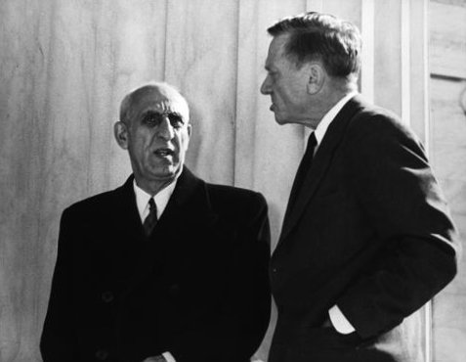*Mohammad Mossadegh Prime Minister, Iran, 1953, while visiting the Supreme Court in Washington D.C., Prime Minister ​ Mohammed Mossadegh of Iran (left) chatted with Associate Justice William O. Douglas. Harry S. Trum. C.C.0, via Wikimedia*

Clerics leveraged the popular dissatisfaction with the Shah, and organized a revolution to overthrow him in 1979. It was at that time several revolutionaries took 52 Americans hostage at the U.S. embassy in Tehran for 444 days (until 1981). A deep rift developed between the U.S. and Iran as a consequence, and hostilities quickly rose between Israel and Iran, as well. These events continue to frame the way Iran is viewed in the U.S. and explain the mistrust between the two countries.

One of the reasons clerics were able to lead the revolution is that they are connected to the people at a grassroots level in Iran. Neighborhood mullahs, who usually provide administrative assistant at the local mosque, are very connected to the families there. They preside over births, deaths, marriages, etc. At the same time a very prominent cleric, Ayatollah Khomeini, was issuing anti-government propaganda that these clerics could rally behind. Eventually, it was Khomeini who became the leader of Iran, usurping the Shah. This began the era of theocracy in Iran.

Key Figure: Ayatollah Khomeini

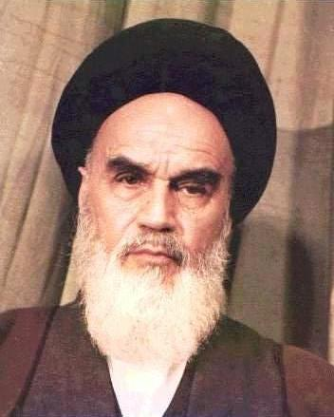

*Image of the Ayatollah Khomeini, by Desconhecido, from Wikimedia Commons C.C.0*

After the Paris Peace Conference of 1919, the mandate system was implemented in the Middle East. Palestine was one of the mandates, as were Syria, Lebanon, Jordan, and Mesopotamia (as Iraq was known). This followed Wilson’s ideals for the League of Nations and was intended to be a method of transition from a condition of colonization to independence. France, Britain, and Russia had negotiated a treaty, the Sykes-Picot Agreement. They agreed in secret on how to divide Ottoman territory amongst them once the war was over.On the political level, the impact of European imperialism can be seen in the form of new notions of national identity. Former imperial powers became nation-states, or their former provinces did. The trade networks and other activities that supported the empire’s power at one time, did not go away but were often subjugated by the new rules of trade agreements with European countries. These agreements favored the interests of the European brokers. The present-day borders of the Middle East were steadily implemented as European powers gained control of provinces of the Ottoman Empire, such as Egypt, and north and West Africa.

These developments, more than the other factors of economics and culture, shaped the geographical definition of what we call the “Middle East.” These events impacted national boundaries and cultural identities in the region. By the time World War I began France and England had enough control over those communities they could conscript from them to bolster their armies, while Germany allied with the Ottomans who conscripted many for the German side.

# Chapter 20 Modernization Versus Westernization

The concept of modernity was an important rationale in projects of European imperialism, and is another element that sets this form of colonization apart from older forms of it. They often attributed their global power to it, and thus their entitlement to have authority over other societies. Looking at modernity as a unique European development, however, does not take into account the influence and competition coming from “The East.” Civilizations such as the Ottoman Empire (Casale,2010) were competitors in the global struggle for dominance, alongside European countries.

Thus, modernity remains one of the important ways both insiders and outsiders of the Middle East conceptualize differences between European communities and the rest of the world. It is in terms of global competition toward technical advancement, in many ways. According to Middle East Historian Marshall Hodgson:

“the gap in development between one part of the world and all the rest becomes decisive, and we must understand its character in order to understand anything else.” p. 176, Hodgson, 1974

Hodgson goes on to explain that the gap had more to do with technological leaps which he called “technicalization”. Yet, from a current postcolonial-theory-based perspective, Hodgson’s use of the term “development” remains a bit problematic. Postcolonial theorist discourse has critiqued the term for its implication that certain countries need Europeans to develop them. This is because it ultimately justifies colonial practices based on the need for “help.”

Modernity makes a strong conceptual connection to cultural imperialism for the above reasons. It was both a rationale of European imperialism, and an economic and social influence. Colonizers engaged in committed efforts to create a local workforce literate in not only in their technologies and methods, but in their cultural norms and worldview. Esposito describes the mentality this way:

“Many Europeans believed that modernity was not only the result of conditions producing the Enlightenment and the industrial revolution, but also due to the inherent superiority of Christianity as a religion and a culture.” Esposito, Forward, Tolan et al, 2013, p. x

This also reflects the close link between religion and culture that was the norm at that time, although secularization was also becoming a major force in Europe and the Middle East.

Despite the pronounced influence Europe had on the Middle East, it is an oversimplification to say that the Middle East was modernized by Europeans.  There is a long memory in regard to scientific and social advancements we mentioned on page 8, and their significance in the world.  The push for modernization was felt most intensely from within, with a constant debate raging about whether that entailed Westernization.

The developed/developing binary is a false dichotomy in many ways. This is partly because modernity has often been defined in contrast with traditionalism. A binary tends to elude critical analysis because of the false choice it presents; that is, they present a superior/inferior construct, with little room for nuance or accuracy.  In the case of the modern/traditional binary, it reinforces many stereotypes that justify the domination of “modernized” or “developed” countries. This is part of of the paradigm of linear “progress” that informs mainstream history textbooks.

While there were many modernizing reformers in Arab countries, three non-Arab modernizers stand out from the post-World War I era.  Mustafa Kemal Ataturk, of Turkey, Reza Shah of Iran, and Amanullah Khan of Afghanistan worked tirelessly to modernize their countries, and even go beyond Western nations in terms of progressive social institutions and women’s rights.  Modernization has been in full force since the 1920s throughout the Middle East. Their social reforms often exceeded the progress in Europe, granting women the right to vote and giving them important roles in the modernizing efforts as educators. Mustafa Kemal Atatürk’s daughter was a pilot. He and other modernizing leaders (see below) implemented liberal secularism throughout government institutions.

Images of Modernizing Leaders, Reza Shah (Iran), Amanullah Khan (Afghanistan), and Mustafa Kemal Atatürk (Turkey):

<https://ohiostate.pressbooks.pub/key2mideast/chapter/westernization-modernization/#modernizing>

# Chapter 21 Gamal Abdul Nasser and Non-Alignment

One of the most prominent figures in resisting imperial control was Egypt’s president, Gamal ‘Abdul Nasser. He was at the forefront of the worldwide movement to resist the domination of the superpowers, called non-Alignment, which denied alliance with either the U.S.’s Containment Policy, or the Soviet Union’s systems of influence. He gained renown at the international conference on the subject in Bandung, in 1955, as a leader in non-Alignment and postcolonial sovereignty.

Key Figure: Gamal ‘Abdul Nasser

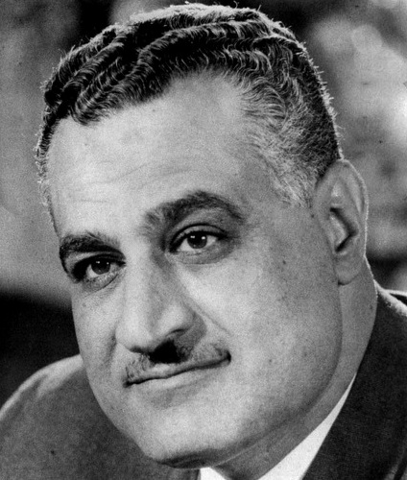

*Gamal ‘Abdul Nasser – Egypt’s president, 1956-1970 – was at the forefront of the worldwide movement to resist the domination of the superpowers, called non-Alignment. He gained renown at the international conference on the subject in Bandung, Indonesia, in 1955.*

Nasser’s policies (Nasserism):

– Pan-Arabism

– Positive Neutrality: This was his non-alignment strategy, neutrality without indifference. This means the sovereign reserves the right to be involved in world affairs without taking sides, necessarily.

– He diverged from Marxist socialism in that he did not abolish private property, or attack systems which protected the rich. Also, considering that Egyptian society considered family as a bedrock, and its religious views were very steadfast, he did not implement anti-religious or family reforms.

Nasser was incredibly popular as he represented Egyptian national identity and independence in many ways. Firstly, because of his role in the revolution of 1952 that overthrew the European-backed monarchy but also because he the first Egyptian to rule Egypt since the time of the Pharoahs, and his humble village background gave him additional authenticity. His credibility was further strengthened when he nationalized the Suez Canal, standing up to both Israel and European powers. Even when Egypt lost the war to Israel in 1967, and lost the Sinai Peninsula, he continued to be considered a hero.

As a way to implement this ideology in his country, and bolster regional solidarity, he developed pan-Arabism to counter the pressures from the West and the Soviets. It was an aspect of Arab socialism which was also gaining traction among Arab intellectuals. Syria and Egypt were united briefly under this policy, and his direction. His main policies were pan-Arabism, and Positive Neutrality. The latter was his non-alignment strategy, neutrality without indifference. The government reserves the right to be involved in world affairs without taking sides, and to intervene on issues deemed appropriate.

# Chapter 22 Nation States and Stateless Nations

It is important to understand the dynamics of national identity for two main reasons:

1) to understand the immense cultural diversity of the Middle East,

2) to understand issues of inequity and power imbalances,

3) to acknowledge that many of the conflicts of the Middle East are better understood with an accounting of national identity issues.

The map of the Middle East is diverse already with Arabic, Hebrew, Turkish and Persian linguistically defining the political borders – not the monolithic image most people have of the Middle East as a location exclusively Arabic-speaking place. However, within those political boundaries, there is even more diversity to be grappled with, and understood. This section gives an overview of national identities and how they formed in the Middle East, and how they differ with European and global views on national identity. It also touches upon the issues of inequity that national identity formation often creates.

National consciousness, government based on national identity, and individual citizenship, has a historical explanation related to power struggles in Europe. The Pope became equivalent to an emperor in Western Europe, because when the Western Roman Empire fell to the Germanic invaders, there was a power vacuum which the Bishop of Rome (now known as the Pope) came to fill. One result of this was a power struggle between “secular” forces, i.e., princes and local rulers, and the Church. The Treaty of Westphalia in 17th Century ended the Thirty Years War and created many of the boundaries in Europe which remain definitive – it also gave the right for each territory to choose its own form of worship. It was a defeat for the Church, but a victory for increased individualism in regard to spirituality and group belonging. Print media played a critical role in the formation of national consciousness as a form of group belonging: reading literature in one’s own vernacular had a powerful effect (Anderson, 2006).

In the Middle East the history of national consciousness differs a great deal from that of Europe.  There were always concepts of cultural community, somewhat synonymous with nation, or people, but national identities were not defined by a particular state.  To take an example from Arabic speaking communities of the Middle East.  A nation, or a people, is usually referred to as qawm in Arabic.  Thus, *qawmia* is usually how the word nationalism is translated.

Likewise, the word umma, which means community and is used by Muslims to refer to their global community, is also sometimes translated as “nation”.  Traditionally, cultural communities were also based on a particular religious tradition.  National identity is therefore a complicated topic in the context of the Middle East.  For the sake of this discussion, however, it is important to know that various cultural communities, whether they called themselves *qawm* or *umum* (plural for *umma*), came to consider themselves nations. At the same time, many of those, did not possess a state of their own, and some continue to be without a state. They are thus “stateless nations”.

Examples of stateless nations:

* The Kurds currently reside in Iraq, Iran, Syria, and Turkey, but they have not established an internationally-recognized state based on their national identity.
* The Jews were a stateless nation until 1948 when they declared Israel a state, and immediately gained recognition from the U.S., followed by the rest of the world.
* Palestinians are currently members of a stateless nation, although the sovereignty of Palestine has been recognized by 135 member countries of the U.N. The term “State of Palestine” is only used officially by Sweden.

Key Concept: Stateless Nation

Various cultural communities came to consider themselves nations and were also able to establish a modern nation-state based on that identity. Many, however, never established their own nation state. They are thus called “stateless nations”.

Many of the nation states of the Middle East formed their national consciousness after the establishment of their state, however. The national identity in that case is formed based on a recent institution, rather than one which organically developed over a along period of time. States that developed their national consciousness after the formation of the state do not have a national history that ties to a unique cultural community. For example, Arab-majority countries of the Middle East all share Arab identity, language and heritage, although they have very different national identities.

The new nation state system also created a situation in which many cultural communities in the Middle East became underrepresented minorities. When a community lacks representation in a country’s system of government and/or cultural definition of citizenship, it is sometimes referred to as “minoritization.” “Minoritize” is a verb used in the social sciences to critically describe the process which creates inequity between groups in a given country (see “Key Concept” below).

Key Concept: Minoritization

“Minoritize” is a verb used in the social sciences to critically describe the processes which create inequity between groups in a given country. As a verb it emphasizes the historical nature of inequity, and as a phenomenon which is continually reinforced in a country. It is the culmination of laws, educational practices and popular culture which favor the perspectives and interests of the more powerful group. It refers to the relationship between the dominant group which identifies with national identity is more supported by the country’s political, social and economic systems, and less powerful communities whose interests are not as well-served by them. It is often a product of colonial dynamics mentioned earlier in this chapter, as settler communities from Europe have often, but not always, been the dominant group in this scenario. For a more detailed explanation, see: Sensoy & Diangelo (2012).

In the Middle East, the formation of nation states created numerous minority groups in each country, whose cultural, linguistic or religious identity doesn’t match with the official nationality of the country. The examples are too numerous to list. The key aspect to be aware of is that the identity of the most powerful group of the country – which is usually also the majority group but not always – doesn’t represent the entire population. For example in Iran the majority identity is Persian-speaking, Shi’i Muslim. There are numerous Kurdish, Arab, Azeri, Assyrian, Jewish, Iranians, among others, and each may be speakers of a different language, and/or adherents to a different religious tradition.

# Chapter 23 The U.S. and Post-Bandung Imperial Dominance

Key Event: Bandung Conference of 1955

By 1955 most colonies had gained independence. The Conference of Bandung in 1955 was a major turning point, which lead to the non-Aligned movement of newly independent countries who wished to resist Soviet and U.S. pressure to align. It was organized by newly independent countries to discuss how to move forward. Its purpose was to discuss two main issues:

With formal colonial structures gone, internal results of the colonial dynamic sometimes became the worst enemy.

Economic relations between rich nations and poor nations, and trade agreements continued to privilege powerful countries and maintain this dynamic, regardless of the official changes in government.

This was the beginning of the non-aligned movement, or the agreement between formerly colonized countries not to join alliances with either superpower.

Pioneers of the non-Alignment movement were Gamal ‘Abdul Nasser of Egypt (see p. 56), Tito of Yugoslavia, Sukarno of Indonesia, and Dawood Khan of Afghanistan. During the Cold War, especially in the 1960’s and 1970’s, it was one of the most significant global movements and the major political weapon for resisting alliance with the superpowers of the time. Nasser was a major proponent of nonalignment, implementing it according to his “positive neutrality” policy in Egypt.

Bandung transformed the history of imperialism dramatically at the same time the U.S. and Soviet Union began vying for global power. Independence and sovereignty became acknowledged rights for every nation state, and an international system was born outside of the imperial system of the past. At the Containment Policy the U.S. implemented to ward of Soviet power during the Cold War created a situation in which newly independent states needed to assert their sovereignty. At the same time groups worldwide continued to bear the effects of colonization, whether former colonies attempting to maintain independence, or minoritized groups and stateless nations continuing their struggle for sovereignty. This section takes an example from Egypt to illustrate these shifting power dynamics. Eisenhower’s policies reflected both a global strategy to gain power, via Soviet Containment, and a respect for sovereignty with regard to the Suez Canal in Egypt.

An example of the colonial dynamics which continued after Bandung, and the assertion of sovereignty by a Middle Eastern country is the conflict over the Suez canal. In 1956 Egypt’s president Nasser nationalized the Suez canal, which had been built in cooperation with France and Britain. As the canal had been a major investment on the part of the French and the British, and it formed a border with Israel, this was seen as an act of aggression by those countries. Israel quickly invaded, receiving the support of France and Britain. Eisenhower, however, sided with Nasser on the grounds that the international community had an obligation to respect the sovereignty of independent nations. Nasser also had the motive of protecting U.S. influence and prevent the Soviets from dominating Egypt, and potentially other Arab states in the region (U.S. Office of the Historian).

Colonial dynamics were shifting toward the superpower competition at that point, and were reflected in the Middle East as pressure to capitulate to one side or the other. The Containment Policy meant that they had to choose whether or not to ally themselves with the U.S. through an international treaty. The most famous of those treaties, the North Atlantic Treaty Organization, or NATO, included Turkey as a member. The Baghdad Pact, which became CENTO after Iraq pulled out, and the South East Asian Treaty Organization (SEATO) were also significant in the region.

Previously, after the first World War, U.S. president Wilson had intervened on the part of Middle Eastern nations in the name of sovereignty with his “14 points,” and theories which led directly to the League of Nations (later, the United Nations). There are differing perspectives on whether the U.S. effectively promoted decolonization, or whether these developments led to a form of neocolonialism, or  neo-imperialism. The mandate system that resulted from the creation of the League of Nations, mentioned previously, is certainly an example of the colonial dynamics we are discussing in this chapter.

Maps of the Alliances of the Cold War Era, Visual of “Containment”: <https://ohiostate.pressbooks.pub/key2mideast/chapter/the-containment-era/#containment>



U.S. foreign policy played a prominent role in the events outlined in this e-book. The 20th century saw the U.S. go from an isolationist country to an influential world player, and what some consider a neo-imperial power. Regardless of how one interprets the meaning of these events, U.S. foreign policy became de facto global rules of engagement. From Wilson’s 14 points and League of Nations, to Truman’s doctrine of containment, to Eisenhower’s implementation of it, the U.S. started to lead global political developments.

The U.S. became increasingly influential on the global economic front, as well. This is indicated by the predominance of U.S. citizens leading such organizations as the World Bank, the International Monetary Fund, the Organization of Economic Cooperation and Development, and the International Energy Agency (Stiglitz,2006). A country must meet the standards of those organizations if they are to be a full participant in the global economy, or global energy trade business.

The Cold War between the U.S. and the U.S.S.R. was the defining global dynamic of the second half of the 20th century. Afghanistan was the lynchpin in the the Middle East between the two superpowers. The occupation of Afghanistan by the U.S.S.R. was its foray into territorial conquest during the cold war era, and was also an attempt to reach a warm water port (Payind,1989). The was a perennial pre-occupation for Russia, as well, and could be seen as a continuation of what Kipling called “The Great Game”.

# Chapter 24 *Conclusion*

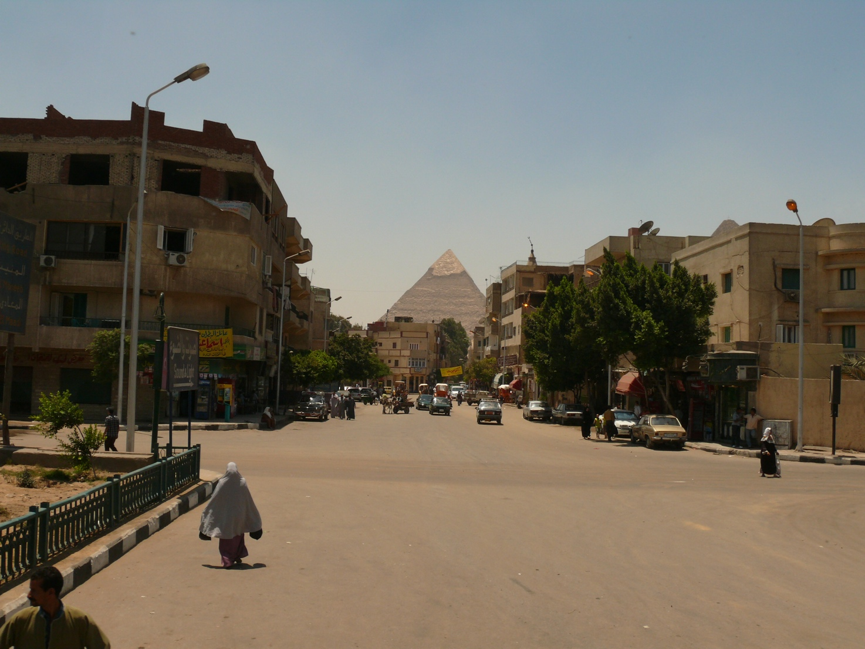

*A street in Giza with the Pyramid of Khafre in the background, by Aligatorek, Source: Wikimedia Commons, License: Creative Commons 3.0*

This street in Giza, a district of modern day Cairo, shows the Pharoanic past juxtaposed with daily life. Why is this not the image one normally sees outside of Egypt? Is it less significant than the battles, the costumes of times past, or the harder-to-glimpse ceremonies and religious practices? Daily life is often the missing piece in cultural information. At the same time, historical background, culturally-held beliefs, and some understanding of social and political perspectives are needed to interpret patterns of activity and the events of daily life.

The information and scholarship you have read herein is a foundation for knowledge, and is intended as a filter incoming information you encounter hereafter. In regard to the goal of building knowledge, we have strived to whittle down the content to those aspects of cultural identity that will make cultural diversity a bit more concrete. In regard to filtering information, or critically parsing through mainstream sources, understanding the diversity of the region is the best preparation for analyzing prominent narratives and images in the media.

As you can see from the street scene on the previous page, there are many layers of history side-by-side in the Middle East. The combinations vary in every local context. In Egypt, Pharoanic, Hellenic, Jewish, Christian and Muslim civilizational imprints exist in every neighborhood – in addition to the Egyptian, Greek, Arabic, Turkic, French, English elements which combined with those in history. Where does connect to the typical Egyptian, or to Egyptian culture in general? Unfortunately, one can’t make any assumptions about how these cultural elements may or may not influence daily life.

The aspects of faith, culture, history and place that we present in this e-book are very general, and do not apply in the same way to every individual with Middle Eastern heritage, or every local context. The nation state dividing lines you see on the map do not indicate real cultural boundaries, either. These general aspects of language, culture and geography will express themselves quite differently from person to person, and place to place.

The communities of West Asia and North Africa underwent and resisted enormous calamities. Gradual suffocation of regional trade and revenues, forced conscription and labor for the war efforts of outsiders, forced migrations which caused many groups to claim genocide, and blockades on internal transport devastated the region we now call the “Middle East” during the era of World War I and just prior.  These factors worked together to kill thousands in North Africa, Anatolia, Greater Syria, Mesopotamia, and Iran by the end of World War One, and shifted demographics.

The main piece of advice we leave you with, as you go on to learn more, is to consider the complexity of local circumstance. For example, the tensions that remain from colonial dynamics do not manifest in the same way in every location or community in the Middle East. An outsider may expect one reaction, but encounter an entirely different one. One may encounter these perspectives during a visit to any given country in the Middle East, of course, but increasingly this happens online. Once you learn to recognize these perspectives, they will become very apparent in both journalistic and scholarly discourses.

One of the most powerful narratives of the Middle East – and it is a powerfully misleading one – is that it has fallen from grace, that it was once an advanced civilization but no longer. AS we mentioned in Chapter Three, a view of the world in terms of “evolution” can create categories of savage/advanced. This is why binaries, such as “traditional” vs. “modern” can be very misleading, and present a major pitfall for understanding this region. Science and discoveries have been a major contribution of the the region, that has often been overlooked in European history. Furthermore, contrary to stereotypical representations of the region, Middle Eastern countries continue to engage in some of the finest scientific research in the world. If you decide to go on to do further research, there will be many pitfalls.

Fortunately, many of them are easily avoidable if you know how to recognize them. The pitfall usually comes in the form of either a romantic notion of some aspect of “culture,” or a demeaning interpretation. This is because most texts do not effectively engage with human differences. Effectively engaging with difference means accepting both commonalities and differences, and questioning aspects you don’t understand. It does not mean judging differences as “strange” or elevating them as “wonderful” – although that is what we tend to do when we are not thinking critically. Connect this academic knowledge with current accounts of daily life, identity and worldview very specifically. Recognize the diversity of the Middle East, and you will be well on your way to gaining a cultural understanding of the region. Ask questions. Be curious. The difference between asking questions before you have this academic knowledge, and after, is that you will be asking informed questions. This goes a long way in opening doors and making personal connections from which you will learn a great deal more than you could from any book.

# Cited Sources

Anderson, B. R. O. (2006). Imagined communities: reflections on the origin and spread of nationalism. London; New York: Verso.

Barks, Coleman. Interpretation of “Only Breath” by Maulana Jallaluddin Balkhi Rumi    <https://www.youtube.com/watch?v=xknm3qKKHKc>

BBCa. Religions – Zoroastrian: Under Persian rule. (n.d.). Retrieved June 25, 2015, from http://[www.bbc.co.uk/religion/religions/zoroastrian/history/persia_1.shtml](http://www.bbc.co.uk/religion/religions/zoroastrian/history/persia_1.shtml)

BBCb. Who, What, & news, W. T. M. answers the questions behind the. (n.d.). Who, What, Why: Who are the Yazidis? Retrieved June 26, 2015, from <http://www.bbc.com/news/blogs-magazine-monitor-28686607>

Casale, G. (2010). The Ottoman age of exploration. Oxford; New York: Oxford University Press.

Case, R. (1993). Key Elements of a Global Perspective. Social Education, 57(6), 318–325.

Center, F. G. E. (n.d.)a. Where Is the Middle East? – Carolina Center for the Study of the Middle East a. Retrieved June 5, 2015, from <http://mideast.unc.edu/where/>

Center, F. G. E. (n.d.)b. Valentine Chirol, 1903. Map based on Chirol’s definition (source: Valentine Chirol, The Middle Eastern Question, or Some Political Problems of Indian Defense (London: John Murray, 1903), 5.) Retrieved from <http://www.unc.edu/mideast/where/chirol-1903.shtml>

Center, F. G. E. (n.d.)c. Alfred T. Mahan, 1902. Map based on Mahan’s definition. (sources: A. T. Mahan, “The Persian Gulf and International Relations,” The National Review, September 1902, 38-39; Roderic H. Davison, “Where Is the Middle East?” Foreign Affairs 38 (1960): 667-668.) Retrieved from <http://www.unc.edu/mideast/where/mahan-1902.shtml>

Cook, J.M. (1985). ’The rise of the Achaemenids and establishment of their empire’ in: Ilya Gershevitch (ed.): The Cambridge History of Iran, vol. II: The Median and Achaemenian Periods, 1985 Cambridge, page 237.

Dandamaev, M. A. (1989). A political history of the Achaemenid empire. Leiden: Brill. p. 373. ISBN 90-04-09172-6.

Diener, A. C., & Hagen, J. (2010). Borderlines and borderlands: political oddities at the edge of the nation-state. Lanham, Md.: Rowman & Littlefield Publishers.

Englehart, O. (2009). Video: Op-Ed: Last Jew in Afghanistan. Retrieved June 9, 2015, from <http://www.nytimes.com/video/opinion/1194839255168/op-ed-last-jew-in-afghanistan.html>

Esposito, J. L. (1999). The Islamic threat: myth or reality? New York: Oxford University Press.

Findley, Carter V. (2004). The Turks in World History. Oxford University Press.

Ferguson, N. (2011, July). The 6 Killer Apps of Prosperity. TED Talk presented at the TED Global Conference, Edinburgh, Scottland. Retrieved from <http://on.ted.com/Ferguson>

Foreman, Laura. (2004). “Alexander the Conqueror: The Epic Story of the Warrior King”, Da Capo Press. pg 80

Hanvey, R. G. (1982). An Attainable Global Perspective. Theory into Practice, 21(3, Global Education), 162–167. Retrieved from http://[www.jstor.org/stable/1476762](http://www.jstor.org/stable/1476762)

Hetzron, R. (1976). Two principles of genetic classification. Lingua, 38, 89–108.

Hodgson, M. G. S. (1974). The venture of Islam : conscience and history in a world civilization. Chicago: University of Chicago Press.

Ibn Khaldun. (2004). The Maqaddimah: An Introduction to History (Bollingen).  Princeton University Press.

Matejic, P. (2012). Eastern Christianity. Presentation for the course “Introduction to the Modern Middle East”, at the Ohio State University.  Columbus, Ohio.

Matthews, P. H. (2003). Linguistics: A Very Short Introduction. Oxford: Oxford University Press.

Merryfield, M. M., & Wilson, A. H. (2005). Social studies and the world : teaching global perspectives. Silver Spring, Md.: National Council for the Social Studies.

Miller, M. C. (2004). Athens and Persia in the Fifth Century BC: A Study in Cultural Receptivity. Cambridge University Press.

O’Donnell, T. (2013, June 8). My talk: JFK Institute, Berlin: How “The Global Barrel” shapes Washington-EU relations. Retrieved from<http://globalbarrel.com/2013/06/08/invitation-to-my-talk-jfk-institute-frei-universitat-berlin-how-the-global-barrel-shapes-washington-eu-relations/#more-998>

Office of the Historian. (n.d.). The Eisenhower Doctrine [U.S. Government]. Retrieved from <https://history.state.gov/milestones/1953-1960/eisenhower-doctrine>

Payind, A. (1989). Soviet-Afghan Relations from Cooperation to Occupation. International Journal of Middle East Studies, 21(1), 107–128.

Paletta, Giulio. Yazidi: sons of the peacock angel | GIULIO PALETTA PHOTOGRAPHY. (n.d.). Retrieved June 26, 2015, from <http://giuliopaletta.photoshelter.com/image/I0000KDOZsL9Buuc>

Rogoff, B. (2003). The cultural nature of human development. Oxford [UK]; New York: Oxford University Press.

Rosling, H. (2009). Let my dataset change your mindset | Video on TED.com. Retrieved February 14, 2013, from <http://www.ted.com/talks/hans_rosling_at_state.html>

Roth, Cecil. (1940). The Jewish Contribution to Civilization,. New York; London: Harper & Brothers.

Ruzic, M., (2015). Christianity:The First Thousand Years. Presentation and Handout for the course “Introduction to the Modern Middle East”, at the Ohio State University.  Columbus, Ohio.

Sensoy, Ö., & DiAngelo, R. (2012). Is Everyone Really equal? An Introduction to Key Concepts in Social Justice Education. New York: Teacher’s College Press.

Stiglitz, J. E. (2006). Making globalization work. New York: W.W. Norton & Co.

Tolan, J. V., Veinstein, G., Laurens, H., & Todd, J. M. (2013). Europe and the Islamic world: a history. Princeton, N.J.: Princeton University Press.

U.S. Government. Egypt under the Protectorate and the 1919 Revolution. (1990). Retrieved from <http://lcweb2.loc.gov/frd/cs/egtoc.html>

Versteegh, K. (2001). The Arabic Language. Edinburgh: Columbia University Press.

Willinsky, J. (1998). Learning to divide the world:education at empire’s end. Minneapolis: University of Minnesota Press.

# The Middle East Studies Center at the Ohio State University

This book was brought to you by the The [Middle East Studies Center](http://mesc.osu.edu/) (MESC) at the Ohio State University. MESC is an area studies center of the [Office of International Affairs](https://oia.osu.edu/) at the Ohio State University.  MESC promotes learner-centered teaching, scholarly exchange, and intercultural experience related to the Middle East. MESC combines efforts with [Near Eastern Languages and Cultures (NELC)](http://nelc.osu.edu/), the [Undergraduate International Studies Program (UISP)](http://internationalstudies.osu.edu/), and the [Middle East Studies Library Collections (MESLC)](http://library.osu.edu/find/collections/middle-east-studies-collection/), to support students, faculty and staff.  Please support our Center’s [Outreach Program](http://mesc.osu.edu/outreach) with a [donation](https://www.giveto.osu.edu/igive/OnlineGiving/fund_results.aspx?Source_Code=WA&Fund=311823). Every dollar directly funds curriculum and its accessibility to the general public, through the creation of easy-to-digest materials, such as this e-book, and our personal delivery of content to schools and teachers in Columbus and across the country, and online. We conduct extensive training for the [military](http://mesc.osu.edu/outreach/military), provide ongoing [media analysis](http://mesc.osu.edu/blog), and continually work to strengthen Middle East studies at OSU by supporting courses, library resources and opportunities for students at OSU.

# Glossary

Aghakhanis

This refers to a Sevener, or Isma’ili Shi’i. This Shi’i group recognizes a living Imam, Karim Ali Khan, or Karim Agha Khan. This term is primarily utilized in Afghanistan and other Central and South Asian countries.

Ahl al-Kitab

A non-Muslim community, usually Jewish or Christian, that, nonetheless is considered legitimate in the eyes of God by Islamic law, or shar‘ia. “People of the Book” is often how it is translated, but “book” is too general in this context. “People of Valid Scrip- ture” would be a more accurate translation, if all the cultural nuances were consid- ered. This is because their prophetic scriptures are recognized as valid in the the Qur’an, as are their prophets.

Allah

This is the Arabic word for God. Arabic speakers, both Muslim and Christian, use the term. It is not specifically the god of Islam, but refers to the God of Adam, Noah, Abraham, Moses and Jesus, as well as Muhammad.

Arabic

This is one of the Semitic languages. It is the language of the Qur’an, the central scripture of Islam. Arabic spread worldwide through Islam, although it did not always become the spoken language of the communities Islam influenced. Many Muslim- majority countries speak languages other than Arabic, but use the Arabic alphabet to write their language, just as we use the Latin alphabet to write in English. For example, Urdu is the language of Pakistan, but it is written in the Arabic script.

Aramaic

This is one of the Semitic language. Jesus’s native tongue was Aramaic. According to Versteegh (2001, p.9, p.94):

“Old Aramaic (first millenium BCE) was spoken at least from the tenth century on- wards in Syria. Between the seventh and the fourth centuries BCE, it was used as a lingua franca in the Balyonian and Persian Empires; it is also the language of some parts of the Jewish Bible. More recent forms of Aramaic are divided into Western and Eastern Aramaic. Western Aramaic was the spoken language of Palestine during the first centuries of the common era, which remained in use as a literary language until the fifth century CE. IT was the official language of the Nabatean and Palmyrene king- doms . . .The most important representatives of Eastern Aramaic were Syriac, the lan- guage of Christian religious literature; Mandean, the language of a large body of Gnos- tic literature. . .and the language of the Balyonian Talmud. . . Modern varieties of Aram- sic survive in a number of linguistic enclaves. . .”

“Eastern Aramaic, usually called Assyrian or Neo-Syriac, is still spoken by approxi- mately 300,000 speakers in Iran, Turkey and Iraq [as of 2001, when Versteegh’s book was published – currently, these communities are under severe threat due to wars in the region]. . .Almost all of them belong to the Christian community.”

Bay‘a

The Arabic word for decision by consensus of a group. Can be translated as group “contract”, or “agreement”.

Caliphate

This is the historic form of government for the (Sunni) Muslim umma, although Shi’i Muslims recognize what they call an Imamate, or Imama, rather than a caliphate. In Arabic, this is called Khilafa. A caliph is a successor to the prophet Muhammad. The role of Caliph refers only to the leader’s temporal powers, however. It specifically does not confer the status of prophet, although it means “successor” of Muhammad. Ac- cording to Islamic doctrine, he was the last prophet, or “the seal of the prophets”. Sometimes caliphs have also been called Sultans. One tradition is to bless the Caliph during the Friday sermon for communal prayer.

Colonial Dynamics

This term refers to the relationship between a powerful country and a less powerful country. It encompasses varying levels of control, and multiple forms of colonization, Western countries have imposed on Middle Eastern countries. The form it takes for the dominated country can range from “colony” to “protectorate” to “mandate”. In the post World War One era, European countries agreed that territories formerly under Ottoman control would be divided between them as “mandates”. This meant that the European powers should assist those countries in becoming independent. Sover- eignty achieved status as a right for every nation-state, and the international system for approaching global affairs was established.

Formal imperialism, with direct control of colonies around the world, and the ability to implement imperial policy from the “mother country”, has not been the predominant form since roughly mid century, marked approximately by the conference in Bandung Indonesia in 1955. Very rich and powerful countries, however, continue to have more power than other countries to set the standards for participation in global economics and political affairs. Forms of economic dominance via the current capital- ist global economic system were developed as part of European colonization; the Dutch/British East India Tea Company, for example, imposed financial and administra- tive systems developed in Europe that continue as institutions today.

Cuneiform

The writing system developed by the Sumerians and later adopted and further devel- oped by the Babylonians, Assyrians and others.

Demotic

This refers to an Ancient Egyptian form of writing, used during the Greek era when the Ptolemes ruled. It is more-or-less a shorthand for heiroglyphics. It is one of the types of writing on the Rosetta Stone.

Diaspora communities

Diaspora comes from the same root word for “spore”, a type of seed which is caught on the wind and spreads far and wide. It refers to cultural communities which have dispersed worldwide, but continue to acknowledge their roots in a particular geo- graphical location.

Emic

Emic refers to a perspective on a phenomenon coming from inside its cultural setting; an insider’s view. Insiders look at their own activities from this point of view, and inter- pret their meaning according to an internal, taken-for-granted cultural framework. Etic is opposite of etic. This is a term taken from anthropology.

Etic

Etic refers to a perspective on a cultural phenomenon coming from a different cultural mindset; an outsider’s view on a cultural community and their practices. Etic is oppo- site of emic. This is a term taken from anthropology.

Hadith

The Hadith are accounts of what the Prophet Muhammad said. They are part of the Sunna of the Prophet, which consists of both his words and his actions. The Sunna constitutes the second most important source of Islamic Law, after the Qur’an.

Hagia Sophia

This is the church founded by Eastern Roman/Byzantine Emperor Justinian (483- 565,CE) in Constantinople (now Istanbul). It was the center of Eastern Christianity. It is now a museum overseen by the government of Turkey, the modern nation state where it is located.

Haj

The Haj, or pilgrimage, is the sacred compulsory visit to Mekka that Muslims must make at least once in their lifetime, provided they have the means. This is one of the Five Pillars of Islam.

Hanafi

One of the major Sunni schools of thought in Islamic jurisprudence.

Hanbali

One of the major Sunni schools of thought in Islamic jurisprudence.

Hebrew

Hebrew is one of the most important Semitic languages. It is the traditional language of the Jewish people, and has become a living language again in Israel, since the late 19th century. It is the language of the central Jewish scripture, the Torah.

Ibadat

This refers to the faith and worship aspects of human life.

Ijtihad

This is a concept in Shar‘ia, or Islamic law. If there is no precedent, a judge must en- gage in the intellectual struggle of Ijtihad. Ijtihad is based on the same root as jihad, indicating the level of effort required for identifying new paths for new circumstances that remain true to God’s will. A specialist in Ijtihad is a Mujtahid.

Imamate

This is the historic form of government for the Muslim umma recognized by Shi’i Mus- lims. In Arabic, it is called Imama. Although Sunni Muslims recognize what they call a Caliphate, or Khilafa, rather than an Imamate.

Ja’afari Shi’i

These are the Shi’i who belong the the Twelver sect, and recognize Ja’afer as the key interpreter of Islamic Law.

Jehovah

This is the English word for God, translated from the Hebrew word Yahweh.

Jihad al-Akbar

The meaning of Jihad is struggle – it can be internal and spiritual/moral (Greater Jihad, or Jihad al-Akbar).

Jihad al-Asghar

The meaning of Jihad is struggle – this form refers to external and physical/combat (Lesser Jihad, or Jihad al-Asghar, which must be against injustice, oppression or invasion).

Jizya

The jizya was a tax for non-Muslims. Aspects of Islamic law, or shar ‘ia, often compen- sated for this. For example certain recognized communities amongst non-Muslims, or ahl al-kitab, were not required to serve in the military.

Ka’aba

This refers to the structure that, according to Islamic tradition, was built by Abraham with his son Isma’il. It is located in Mekka, in what is now Sa‘udi Arabia, and marks the center of Muslim prayer worldwide, or the qibla, in Arabic. Circumambulating it is a required part of Haj.

Khariji

Secessionist from the Muslim community, or Umma.

Khuda

This is the Persian word for God.

Kurdish

This is a significant member of the Indo-Iranian language family, spoken by Kurdish populations in Syria, Turkey, Iraq and Iran.

League of Nations

The organization was established based Woodrow Wilson’s 14 points in the 1920’s. It later became the United Nations. Both organizations have played a defining role in the political affairs of the Middle East.

Liminal

The word liminal is used in the humanities and sometimes in the social sciences to re- fer to a person or location that exists on the border between two worlds. This is espe- cially in reference to cultural boundaries.

Magna Carta

The Magna Carta was an agreement signed by King John of England on June 15, 1215, to appease nobles, and guarantee his accountability to his subjects. Account- ability of the state toward its citizens became one of the fundamental tenets of West- ern democracy, and was likely patterned after the ideas in this document.

Maliki

One of the major Sunni schools of thought in Islamic jurisprudence.

Mandate System

This codified a the new international policy of gradual self-rule for colonized countries. It was based on Wilson’s 14 points, and diverged from the previous overtly competitive nature of colonial policy. Many of the modern borders of the Middle East reflect the borders defined by the post-World War I mandates.

Millet

Islamic states tolerated religious laws of non-Muslim communities, provided they had status as a “people of the book” or ahl al-kitab. The Ottomans called these communi- ties millet, which is sometimes translated as nation. Because their prophets and scrip- tures are recognized, ahl al-Kitab were allowed to continue their religious and commu- nal functions within the larger Ottoman context. At the same time they had different rights and obligations than their Muslim counterparts. For example, the jizya was a tax for non-Muslims, while they were not required to serve in the military.

Minoritization

“Minoritize” is a verb used in the social sciences to critically describe the processes which create inequity between groups in a given country. As a verb it emphasizes the historical nature of inequity, and as a phenomenon which is continually reinforced in a country. It is the culmination of laws, educational practices and popular culture which favor the perspectives and interests of the more powerful group. It refers to the rela- tionship between the dominant group which identifies with national identity is more supported by the country’s political, social and economic systems, and less powerful communities whose interests are not as well-served by them. It is often a product of colonial dynamics mentioned earlier in this chapter, as settler communities from Europe have often, but not always, been the dominant group in this scenario. For a more detailed explanation, see: Sensoy & DiAngelo (2012).

Mission Civilisatrice

The French policy towards its colonies and other areas of the world considered less advanced. It was based on the common conceptions of culture, and the belief that because cultures “progressed” certain cultural communities were less developed and required help to become more “advanced”.

Mizrachim

“Mizrahi Jews, Mizrahim (Hebrew: מזרחים) or Mashriqiyyun (Arabic: المشرقيون), also re-

ferred to as Edot HaMizrach(עֲד ת–הַ ִזְ ח; Communities of the East; Mizrahi Hebrew: ʿEdot(h) Ha(m)Mizraḥ), Ben ha-Mizraḥ; Bene ha-Mizraḥ(“Sons of the East”) or Oriental Jews,[3] are Jews descended from local Jewish communities of the Middle East. The term Mizrahi is most commonly used in Israel to refer to Jews who trace their roots back to Muslim-majority countries.”

Wikipedia Entry, “Mizrahi Jews”

Modernity

This term refers to multiple aspects of technical and scientific developments centered in Europe, and is based on the idea that human civilization can “progress” over time. The concept of modernity was an important rationale in colonization projects of Euro- pean imperial powers. There are different ways of conceptualizing modernity, how- ever. A less Euro-centric definition acknowledges the scientific sophistication of non- European countries and communities. Despite the pronounced influence Europe had on the Middle East, it is an oversimplification to say that the Middle East was modern- ized by Europeans. The push for modernization was felt most intensely from within, with a constant debate raging about whether that entailed Westernization. On page 50 there is a gallery with modernizing leaders of the Middle East who began their re- forms in the post World War One era.

Mu’amilat

This refers to the outer aspects of human life; i.e., work life, family/household, commu- nity service, etc.

Muadhans

This refers to the individuals who call people to prayer, and provide other aspects of prayer service, with religiously prescribed songs. The “dh” is pronounced like the “th” in the word “the”. It is pronounced Muazhan more commonly.

Mujtahids

Jurist scholars, or those who practice *ijtihad*.

Mutual Intelligibility

The ability of one speaker to make him or herself understood to another, and vice versa. This is the way a linguist evaluates the distance between two forms of speech; i.e., whether or not they are two distinct languages.

Pan-Arabism

This is an Arab-centered form of nationalism inclusive of aspirations for Arab unity. President Nasser of Egypt was a proponent.

Persian

Persian is the main language spoken in Iran, Afghanistan, and Tajikistan. Being an Indo-Iranian language, and part of the Indo-European family of languages, it is much closer to English in structure than the Semitic or Turkic languages. Practices from Achaemenian, Sassanian and other Persian civilizations show up in modern concepts of literature, the arts and courtly life.

Pharoanic

This refers to the cultural setting of Ancient Egypt, as opposed to later Christian and Islamic cultural norms.

Pogroms

“A pogrom is a violent riot aimed at the massacre or persecution of an ethnic or relig- ious group, particularly one aimed at Jews. The term originally entered the English lan- guage in order to describe 19th- and 20th-century attacks on Jews in the Russian Em- pire (mostly within the Pale of Settlement, what would become Ukraine and Belarus). Similar attacks against Jews at other times and places also became retrospectively known as pogroms. The word is now also sometimes used to describe publicly sanc- tioned purgative attacks against non-Jewish ethnic or religious groups.”

-Wikipedia Entry “Pogrom”

Positive Neutrality

This was Nasser’s non-alignment strategy, neutrality without indifference. This means that a sovereign state reserves the right to be involved in world affairs without taking sides, necessarily.

Prestige Language

A language which gains more prestige than others in society because of its impor- tance in education, administration, commerce, and/or other factors. Gradually this may take hold in people’s homes as they increasingly adopt it as their mother tongue. This happened in many of the countries which became Muslim (but not all). This is a concept from the field of socio-linguistics.

Protectorates

Territories endowed with semi-autonomous government. The Sultanate of Egypt (1914-1919) was one of those, a short-lived protectorate of the British Empire. A local king was placed in power, but the purpose was mainly to sever it from the Ottoman Empire during World War I (L.O.C., Egypt).

Qawmia

This is an Arabic term that is usually translated as nationalism. It comes from the Ara- bic word for a people, qawm.

Qur’an

The primary scripture of Islam. According the Muslims, Prophet Muhammed received messages from God through the angel Gabriel, which he recited, and others memo- rized and wrote down. The Caliph Uthman (644-656 C.E.) codified the fragments of the Qur’an in circulation and unified them into a book.

Ramadhan

This is one of the months in the Muslim calendar, which is a lunar calendar. This month does not correspond with any month in the Gregorian calendar, and so gradu- ally moves throughout the year. It is the time period designated for reflection and fast- ing. Observant Muslims refrain from food, water, sex and smoking during daylight hours. They are also supposed to remain in control of their thoughts and emotions, treating those around them in a way which is pleasing to God. The traditional food for breaking fast is the date. The Prophet Muhammad is said to have broken his daily fast during this month with dates and camel’s milk. At the end of the month there is a celebration called ‘Eid al-Fitr, or Ramazan Bayramı, in Turkey. The entire month is a time for family and connecting with loved ones, but especially during that holiday.

Salafi

*Salaf* means ancestors, and the Salafis, or followers of the Salaf, believe that the relig- ious and temporal practices of the earliest Muslims and companions of the prophet provide a comprehensive guide for religious life and government.

SAVAK

Sazeman e Et-tela va Aminiyat e Keshvar (SAVAK), or security and intelligence serv- ice, was the secret service of Iranian Shah, Muhammad Reza Shah.

Shafi‘i

One of the major Sunni schools of thought in Islamic jurisprudence.

Shar‘ia

This refers to Islamic law. There are two distinct realms for religious oversight: faith and worship (ibadat); temporal and worldly activity (mu’amilat). The Shar’ia, is a sys- tem of law which covers both facets. Its purpose is to both guide the conduct of Mus- lim communities, and also to serve as a basis for government in Islamic states.

Shi’i

A Shi’i is a Partisan of ‘Ali, or, Shi’at ‘Ali, in the full Arabic phrase. Shi’ite is a another standard term in English for Shi’i. ‘Ali was the Prophet’s cousin, his daughter’s hus- band, and as his only living male heir, the preferred candidate by many for taking on leadership of the Muslim community, after Muhammad passed away. These partisans disagreed with the decision to make Abu Bakr the Prophet’s successor for political leadership (no one could inherit his spiritual role as a prophet). See page 37 for infor- mation on Shi’i splinter groups.

Sufism, or Tasawwuf

Sufism, or Tasawwuf, is the mystic path within Islam. It has produced much of Islam’s philosophical content, as well as provided a means for dissent. Many folk practices  
 of Islam center on a mystic figure, or wali. The maintenance of wali shrines, and visita- tion to the mausoleums of revered spiritual figures, are major practices within Muslim communities around the world.

Sunna

This is a revered word when used in the context of Islam. A sunna was a path worn into the sand, hardening the sand with perpetual use.  It came to stand for tradition.  In Bedouin culture, the nomadic culture of the Arabian Peninsula, such paths are very important, as unknown territory could be deadly.   Over time, the word some of its original complexity, but it has kept the meaning of correct path, or tradition.  Sunni Muslims can be translated literally as “Muslims following the sunna, or the right path, or the traditions of the Prophet.”

Sunni

Just after the death of the prophet in 632, C.E., there was disagreement over who should be his successor. A meeting was convened, and the prophet’s friend Abu Bakr was chosen by the group. Those who agree with that decision call themselves followers of the traditions, or Sunna, of Islam. They are thus called Sunnis. The differences between Shi‘i and Sunni Muslims are primarily focused on this history, and not as much on religious activities or doctrine.

Talmud

Talmud means “teachings”, and is the primary text in Jewish scholarly, or Rabbinic, literature. It is written in Aramaic and Hebrew. It is one of the bases for Jewish Law, or the Khalakha.

Technicalization

Technological leaps which provided Europeans advantages in the global competition to control resources. This is Middle East historian, Marshall Hodgson’s term (1974).

Temple Mount

It was the location of Judaism’s first and second temples (built by Solomon and David, respectively), which remain central to Jewish spirituality and traditions. Medieval Christian Europe centered its geography on Jerusalem (Willinsky, 1998), the landscape of the Christian Bible. According the Christian’s, Jesus is the rightful heir of David and his temple. The Dome of the Rock (gold dome above), and the al-Aqsa mosque, sacred to Muslims, are located on it. This site marked the center of Muslim prayer worldwide, prior to the direction being moved to the Ka’aba.

The Great Game

This term was popularized by Rudyard Kipling, a well-known literary figure who wrote about British colonial experience, especially in regard to what was then “the Indian subcontinent” (inclusive of Bangladesh and Pakistan). It refers to the competition to control Indian territory, especially in the region of what is now Afghanistan and Pakistan, between Russia and Great Britain.

The Rosetta Stone

The Rosetta Stone, with inscriptions in Hieroglyphics, Egyptian Demotic and Greek. The inscriptions were of the same message, but in different tongues and writing sys- tem, allowing scholars to decipher Ancient Egyptian Hieroglyphics. Discovered by Na- poleon’s team of scholars in Rosetta, Egypt, in 1799, this artifact now symbolizes the act of decoding and uncovering lost knowledge.

The Sykes-Picot Agreement

France, Britain and Russia negotiated a treaty in secret prior to the end of World War One, a plan for dividing Ottoman territory amongst them once the war was over.

Torah

This refers to Jewish scripture; specifically, the five books of Moses.

Transliteration

The process of transferring phonemes from one writing system to another. This can also be referred to as Romanization, in the case of transcription into the Latin alphabet. For example, taking an Arabic word written in the Arabic alphabet, and writing it in the Latin Alphabet. It implies that care has been taken to correctly represent the sounds of the word in Arabic, according to a scholarly standard. We use the American Library Association-Library of Congress standard in this book.

Treaty of Westphalia

This 17th century treaty ended the Thirty Years War, and defined sovereignty as a re- spect for political borders. This is the basis for modern conceptions of statehood.

Turkish

This is the official language of Turkey, and a member of the Turkic language family.

Umma

This is the Arabic word for “the Muslim community.” It is sometimes also translated as “nation”. It can also mean, simply, community.

Usul al-Fiqh

Religious legal interpretation, or fiqh, encompasses nearly every permutation of social structure, area of human activity and aspect of government. The usul al-Fiqh are the sources of Islamic legal interpretation. These sources are used according the se- quence below:

1. The Qur’an
2. The Sunna
3. The consensus of jurist scholars
4. Analogy by deduction
5. Ijtihad, or the application of all four prior sources toward an unprecedented case.

The Qu’ran is the most important source, and must be looked to first, but it is not the only source. There is a massive body of law from which scholars of Islamic jurispru- dence may draw upon.

*Warda*

This is the Arabic word for Rose. It originally entered Arabic from Avestan Persian.

*Yahweh*

This is the Hebrew word for God.

Yazidis

From the BBC (BBCb):

“Their own name for themselves is Daasin (plural Dawaaseen), which is taken from the name of an old Nestorian – the Ancient Church of the East – diocese, for many of their beliefs are derived from Christianity. They revere both the Bible and the Koran, but much of their own tradition is oral. Due in part to its secrecy, there have been mis- understandings that the complex Yazidi faith is linked to Zoroastrianism with a light/ dark duality and even sun worship. Recent scholarship, however, has shown that al- though their shrines are often decorated with the sun and that graves point east to- wards the sunrise, they share many elements with Christianity and Islam.”

Zoroastrian Equinox Holidays, Now Ruz/Mehregan

Now Ruz and Mehregan refer to the Spring Equinox and the Autumn equinox, respec- tively. Now Ruz, means “new day”, and is celebrated as the new year across much of the Middle East, especially among communities who speak languages of the Indo- Iranian family, such as Kurds, Iranians and Persian- speakers throughout Central Asia.

Zoroastrianism

Its founder, Zoroaster, was born in what is now Afghanistan, and the faith continues among a small number of adherents in Iran, India, and other parts of the world. Muslim and non-Muslim communities in Iran, Afghanistan, Pakistan, and Central Asian countries continue to practice its traditions alongside their religious practices. For example, marking the Spring Equinox in the festival of Now Ruz is a major traditional holiday in Iran, Afghanistan, Central Asia, and Pakistan. The scripture of Zoroastrianism is the Avesta.