VLS 2.0 – Academic Success Strategies in a Virtual Environment
  - Instructions for Course Adaptation

Importing into Moodle
There are five stages to importing the template into your Moodle course:
- Download the import package from the eCampusOntario VLS Collection.
- Unzip the package. You will find two files: “template-package.mbz” and “moodle-adv-int-widget.html”.
  - “template-package.mbz” contains the template package
- Check your Moodle settings (see Stage 3 below).
- Import the template files (see Stage 4 below).
- Configure your HTML “Welcome” widget (see Stage 5 below).

Assuming you have already completed Stages 1 and 2, proceed to Stage 3:

Stage 3: Check your Moodle settings
To host the interactive components, you will need to create a widget. This will require you to add an HTML block to your course page. You will first need to confirm that your institution’s Moodle instance has the ability to add HTML blocks.
To verify the ability to add HTML blocks:
- Click on the “Turn editing on” button. This will put you in edit mode.
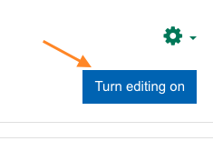
- On the left side of the navigation menu, scroll down and click on “+Add a block”.
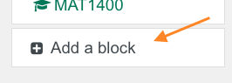
- A window should appear with the heading “Add a block”. Scroll down and you should see a block that says “HTML”. If you see “HTML”, click the cancel button and proceed to Step 4.
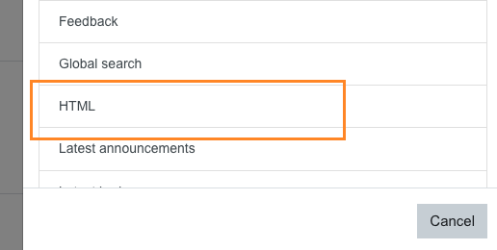

NOTE
If you do not see the option to add an HTML block, please check with your institution to see if this setting can be turned on or enabled. You will not be able to add the interactive components if this setting is not enabled.

Stage 4: Import the template files
The template package contains the content and files that need to be imported into your course. To do this, use the “Restore” function in Moodle:
- Click the gear icon near the top left of your course page and select “Restore”.
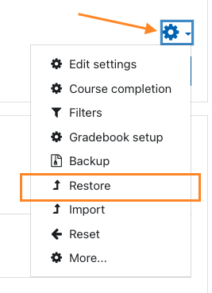
- Locate the “template-package.mbz” file on your computer (from Stage 2). Under the “Import a backup file” section, drag and drop this file into the designated drop area and click the “Restore” button.
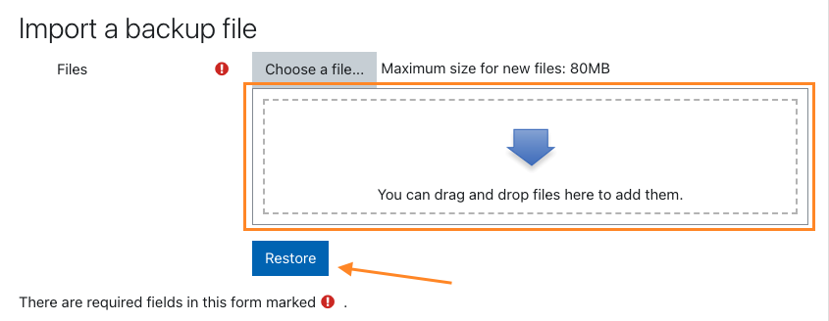
- Click the “Continue” button until you reach the “Restore into this course” section. Make sure the “Merge the backup course into this course” option is selected, then click “Continue”.
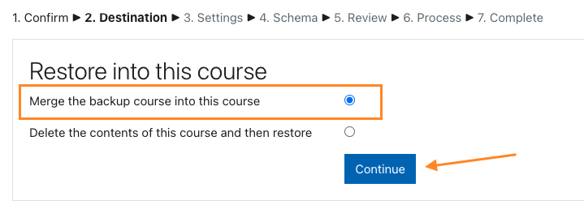
- Click “Next” and the “Course setting” section will appear. In this section, make sure that the “Overwrite course configuration” is set to “No”. This will grey-out the options to "overwrite", ensuring the course name and short names are not overwritten by the template. Click the “Next” button found at the bottom of this section.
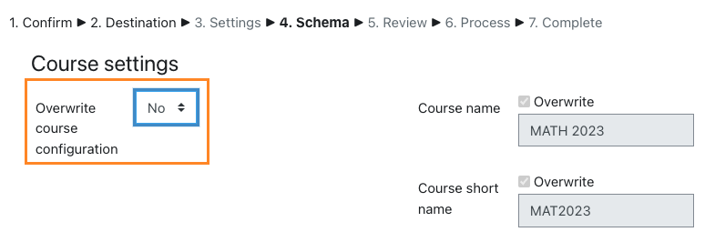
- Finally, click the “Perform restore” button at the bottom of the page, then click “Continue”.

Stage 5: Configure your HTML “Welcome” widget
This final stage makes the template and interactive components function in your course. Complete the following:
- On your course home page, locate the “Faculty How to Guide” module. Inside this module, click on the “Template_Files_durcol” folder. Note that both the module and the folder will be automatically hidden when edit mode is turned off. Please do not rename or manually hide using the “hide topic” option to avoid any issues with using the template.
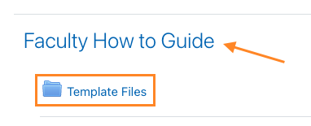
- Click to open the “click-me-to-get-link.txt” file. A blank file will open. Copy the URL displayed in your browser’s URL field (e.g. “http://moodle.local/pluginfile.php/324/mod_folder/content/0/click-me-to-get-link-.txt”).
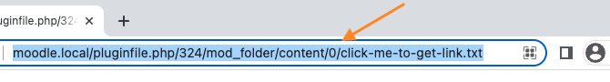
- Navigate back to your course home page. Click the “Turn editing on” button.
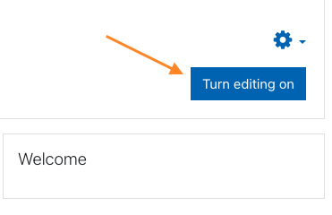
- The gear icon for the “Welcome” widget should now be visible. Click this icon and select “Configure Welcome block”.
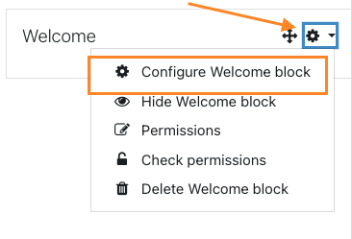
- Under the “Content” section, click the “Show More” button (1), then click the “HTML” button (2) that will appear on the bottom row.
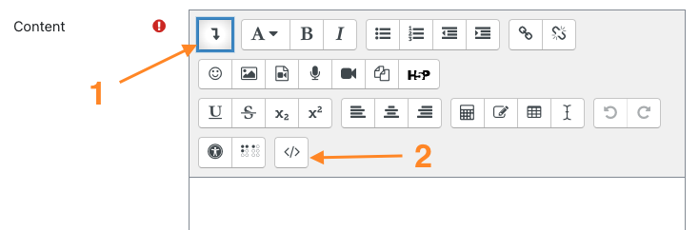
- On line 12 you will see the text “let linkLocation = ‘’”. Paste the URL that was copied in Step 2 between the single quotes. Check line 10 and ensure that the text in single quotes matches the beginning of your pasted URL (either “http” or “https”). On line 12, delete the text “http://” or “https://” from the beginning of the pasted URL and delete “click-me-to-get-link.txt” from the end of the URL. You should be left with something like this:

let linkLocation = ‘moodle.local/pluginfile.php/324/mod_folder/content/0/’
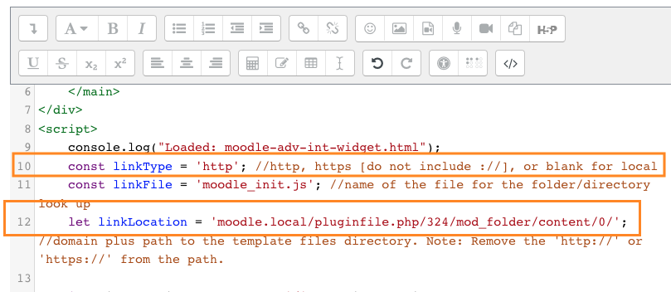
- Click “Save changes”. You should now see the “Interactive Components” widget. Visit the “Components Demo Page” in the “Faculty How to Guide” to see how each component functions and to learn how to add them to your course.

NOTE
If your course is copied (e.g. new semester/additional section), you will need to repeat Stage 5 in the new course to update the HTML “Welcome” widget.

Happy Developing!
This project is made possible with funding by the Government of Ontario and through eCampusOntario’s support of the Virtual Learning Strategy. To learn more about the Virtual Learning Strategy visit: https://vls.ecampusontario.ca.

This work is licensed under Creative Commons Attribution-NonCommercial-ShareAlike 4.0 International.

Quiz Builder Instructions
The Quiz Builder helps you to build an interactive formative (practice) quiz that you can embed into your course content. The quiz builder is easy to use with only three steps:
- Setup
- Customize
- Copy Code

Step 1: Setup
The Quiz Builder can be customized based on your needs. In this step, you will setup your quiz based on the following options:
Option | Description
Number of Questions per Quiz | Specify the number of questions you would like to feature in your practice quiz. You will be able to select the types of questions in your quiz when you customize your quiz in Step 2.
Number of Options per Question | Specify the maximum number of options available for each question. This option will apply to multiple choice, multi-select or reorder question types. If your quiz questions will not all have the same number of options, enter the highest number of options. You can leave unnecessary options blank in a question to omit them. Example: if a quiz consists of one question with four options and one question with six options, enter “6” and leave the two extra options blank for the question that has four options.
Randomize Question Order | This allows you to randomize the order of quiz questions when a student loads or refreshes the content page.
Add Panel | This allows you to enclose your question in a formatted panel container. It adds a style element to the quiz.
Panel Type | If you choose to add a panel, you can also make the panel collapsible. This is useful if your quiz contains several questions and you want to reduce scrolling.

Once you are happy with your quiz setup and are ready to proceed to Step 2, click the “Generate Code” button, then click “OK”.

Step 2: Customize
You can customize your quiz and add content to your quiz questions using the following options:
Option | Description
Panel Title (if applicable) | If you choose to have a panel, you can give it a title. Example: Check Your Knowledge.
Question Type | Select the type of question from the available options. The question fields will change based on the type of question you pick.
Question Text (required) | Type or paste the text for your question. This field is required.
Option Text (if applicable) | The option text may not be available, depending on the question type. You may leave options blank to omit those options from displaying for the question.
Include hint or feedback type for each question | You can add either a hint or feedback for students. A hint will provide a clue for students who are stuck answering the question. Feedback will give students a deeper understanding of the correct answer.
The Correct Option(s) (required if applicable) | This option is required if the question requires a correct selection. Example: multiple choice, multi-select or true or false questions.
Randomize the options order (if applicable) | You may customize this option for each question. If applicable to the question type, you can choose to randomize the order of question options when a student loads or refreshes the content page.
Next and Previous Chevron buttons | Use the left and right chevron buttons to move between questions if your quiz contains more than one question.

Click the “Push to Preview” button once you are ready to preview your quiz, then click “OK”. If you are happy with the quiz preview, proceed to Step 3. Otherwise, return to Step 1 or Step 2 to edit your quiz. (Note: if you edit Step 1 you will need to re-enter the information in Step 2.)

Step 3: Copy Code
Click the “Copy Embed Code </>” button to copy the embed code to be pasted into your course content.

